<https://www.youtube.com/watch?v=D0efHEJsfHo&list=PLblh5JKOoLUICTaGLRoHQDuF_7q2GfuJF&index=41>



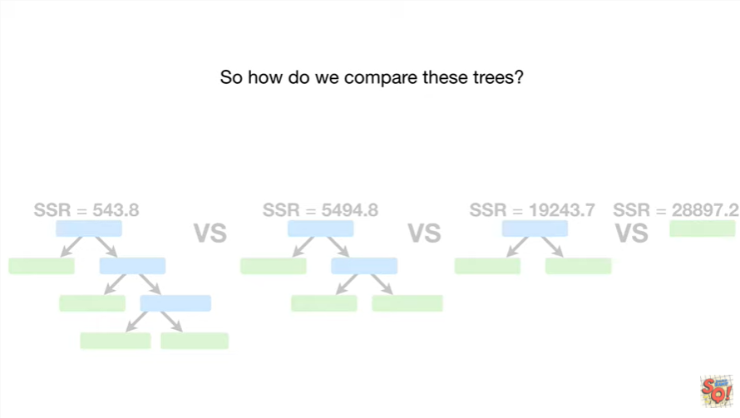

So how do we compare these trees ?

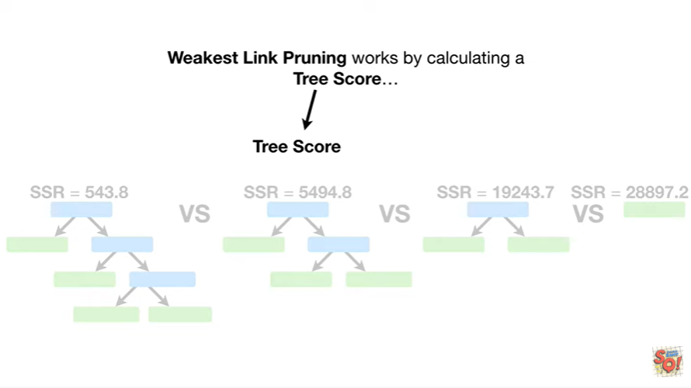

Weakest link pruning works by calculating a tree score

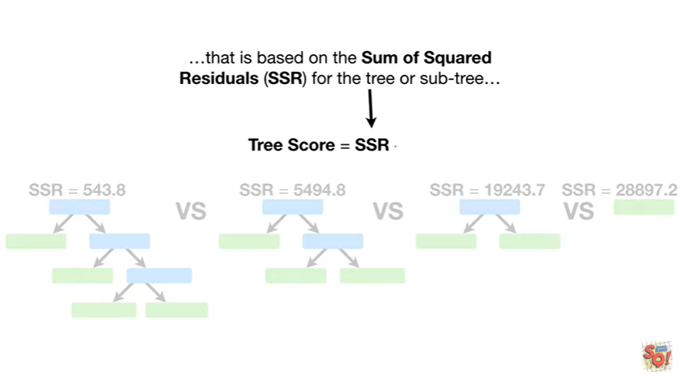

that is based on the sum of squared residuals for the tree or subtree

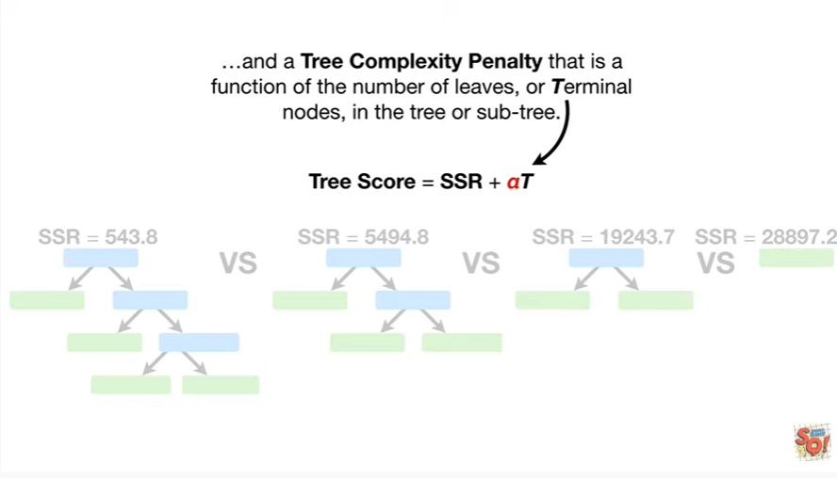

and a tree complexity penalty that is a function of the number of leaves or terminal nodes, in the tree or subtree.

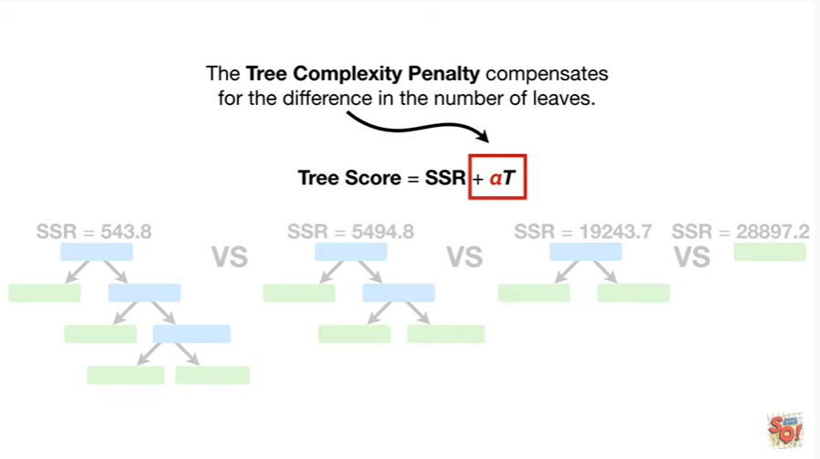

The tree complexity penalty compensates for the difference in the number of leaves.

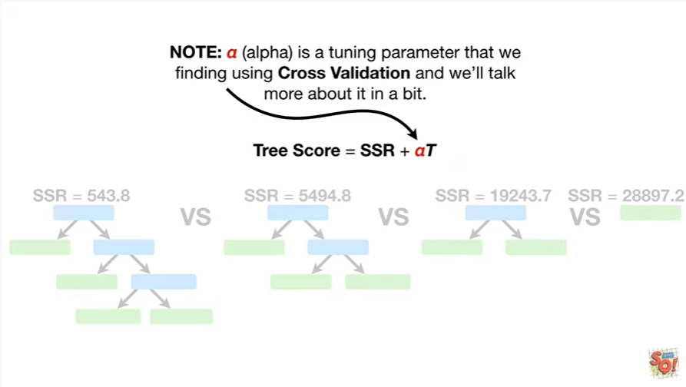

Note : alpha is a tuning parameter that we find using cross-validation and we'll talk more about it in a bit.

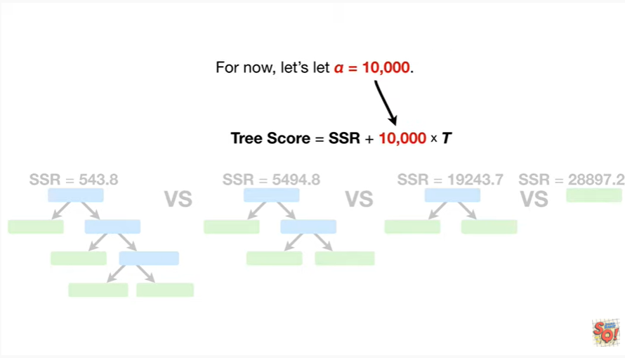

For now let's let alpha equal 10,000.

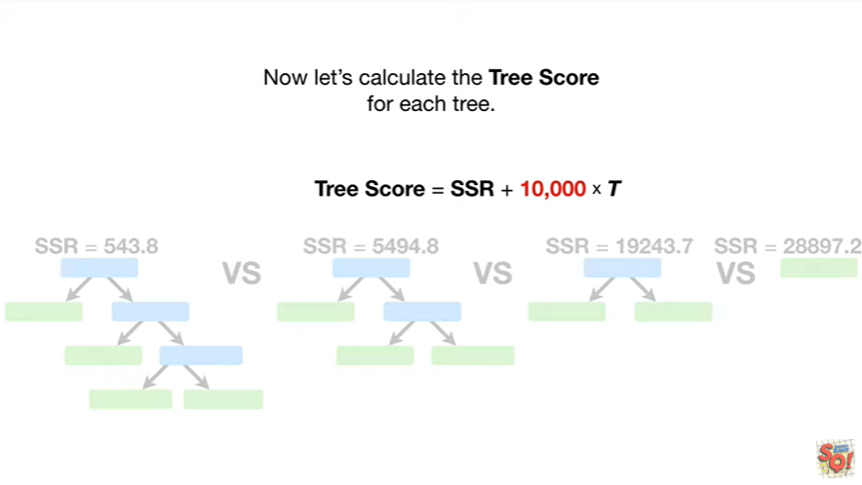

Now let's calculate the tree score for each tree.

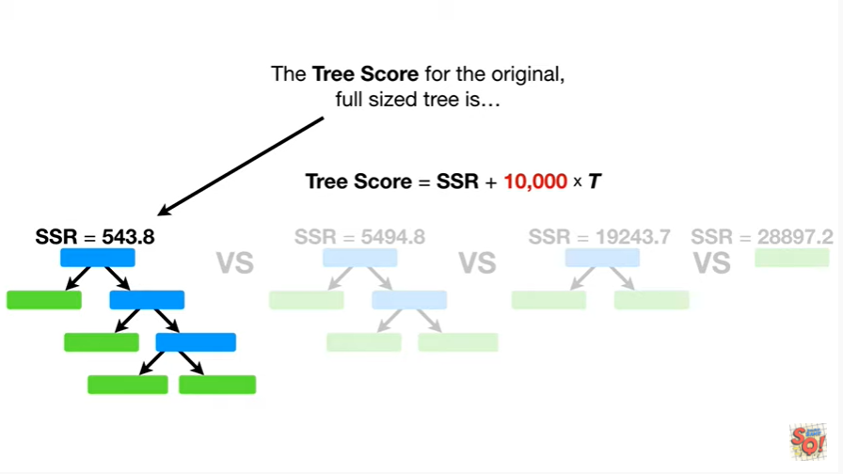

The tree score for the original full-sized tree is

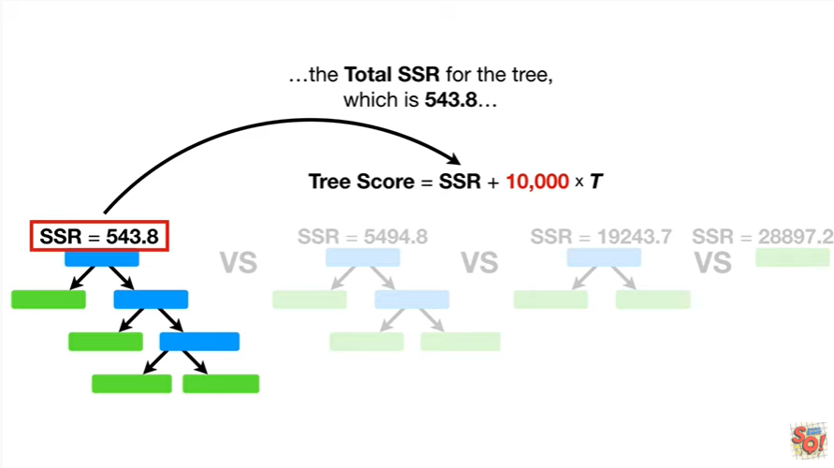

the total SSR for the tree which is five hundred forty three point eight

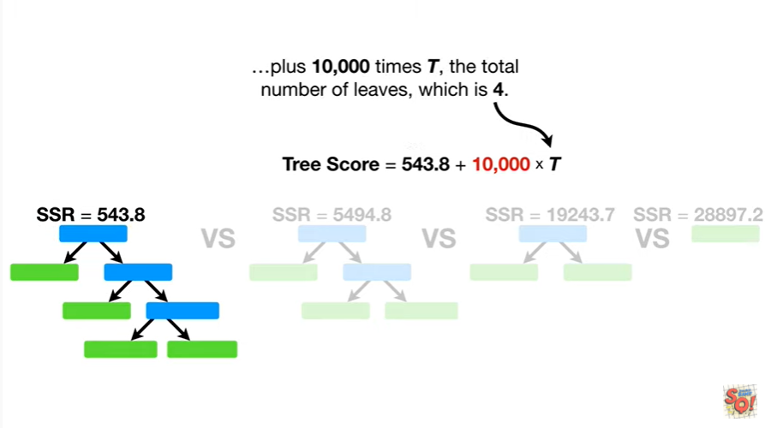

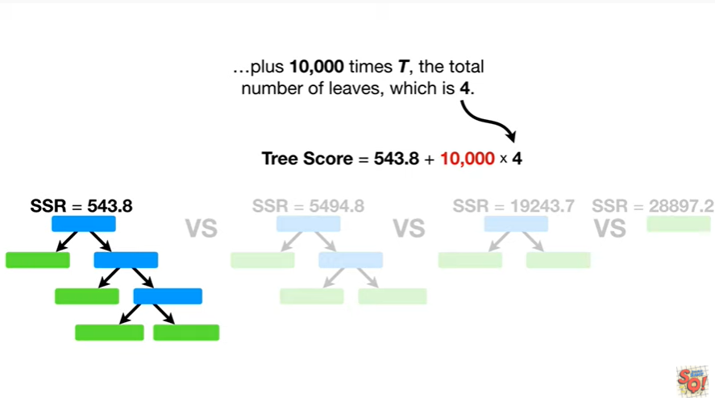

plus ten thousand times T the total number of leaves which is four.

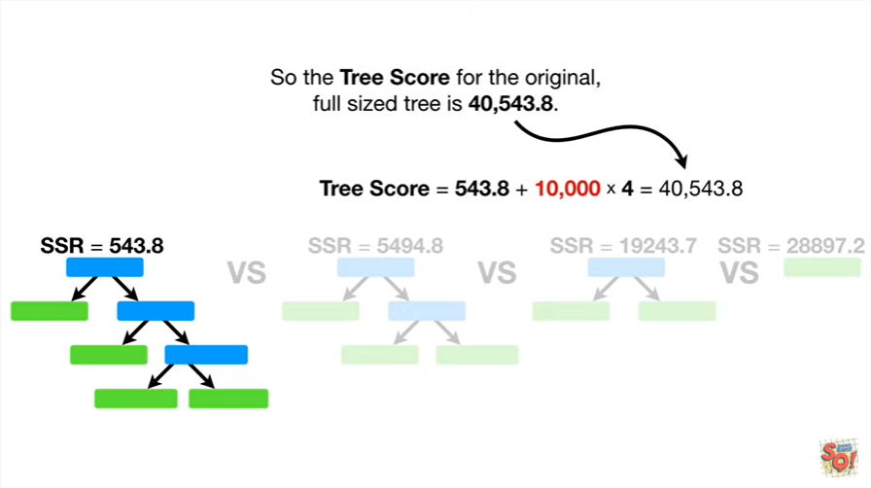

So the tree score for the original full-size tree is forty thousand five hundred forty three point eight.

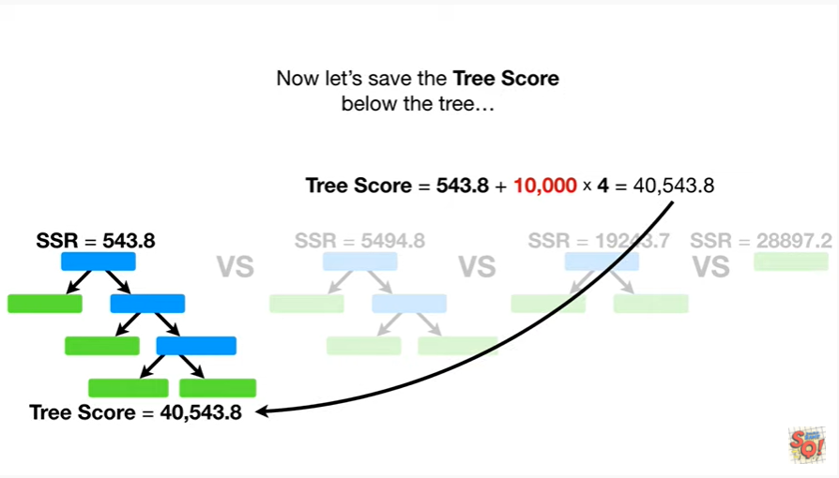

Now let's save the tree score below the tree

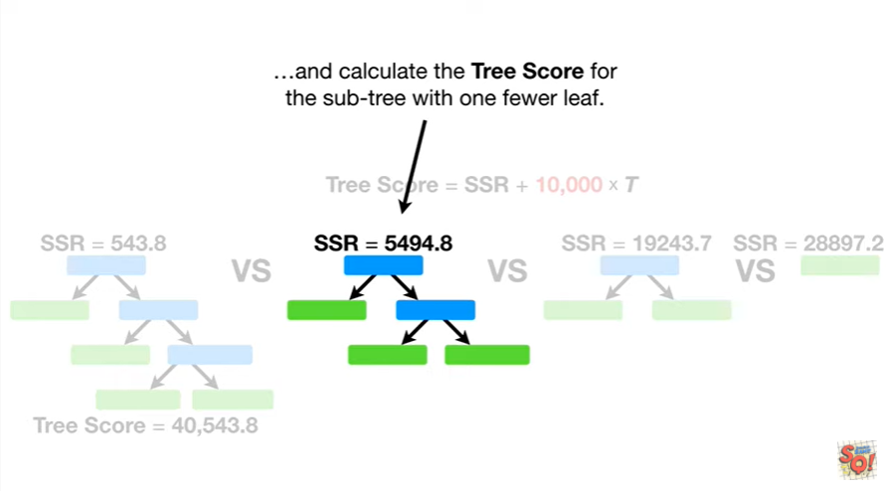

and calculate the tree score for the subtree with one fewer leaf.

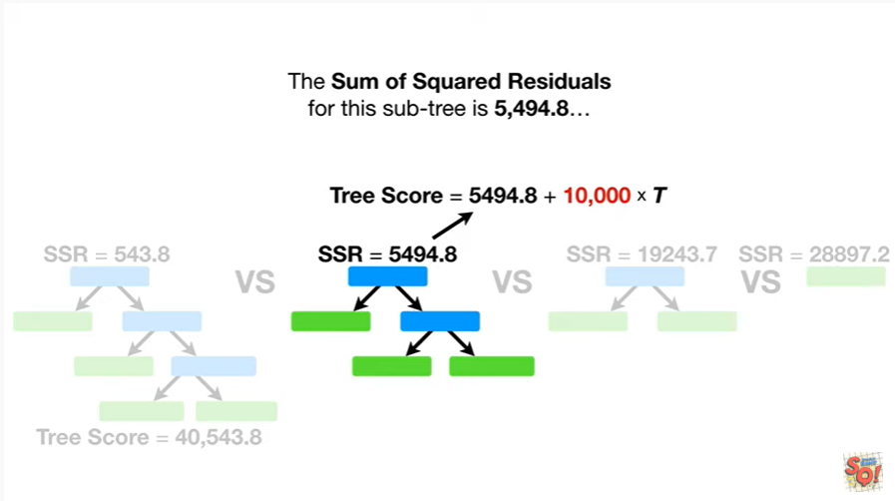

The sum of squared residuals for this subtree is five thousand four hundred ninety four point eight

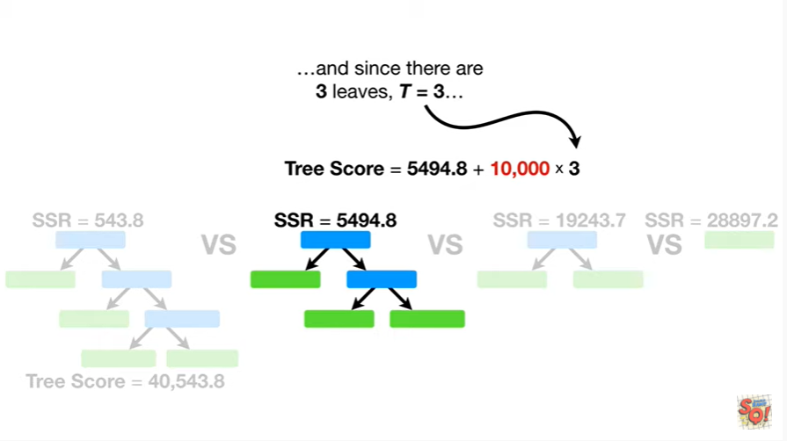

and since there are three leaves T equals three

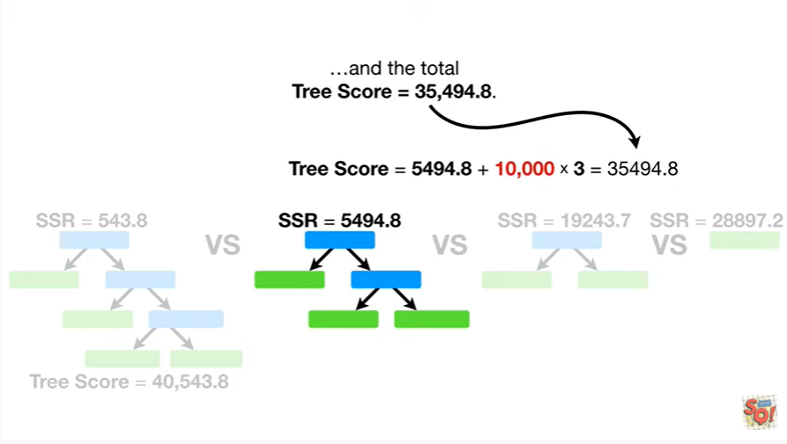

and the total tree score equals thirty-five thousand four hundred ninety four point eight.

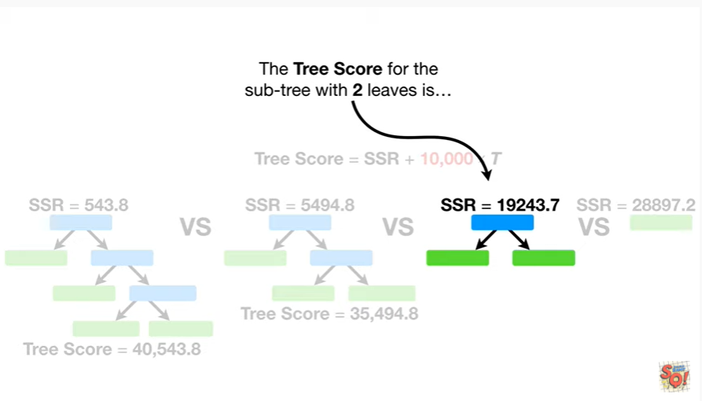

The tree score for the subtree with two leaves is

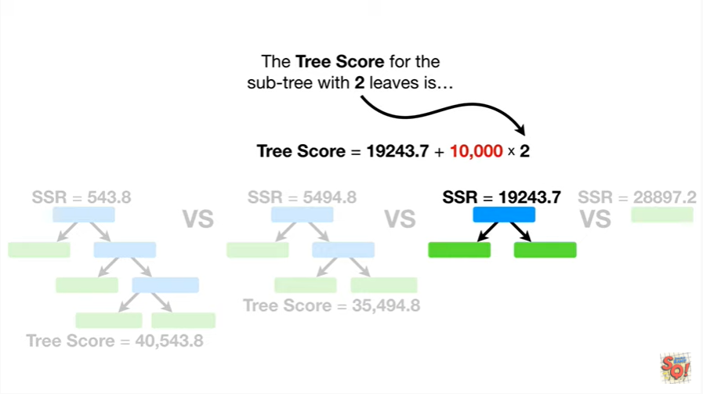

be boo-boo-boo-boo-boo-boo-boop

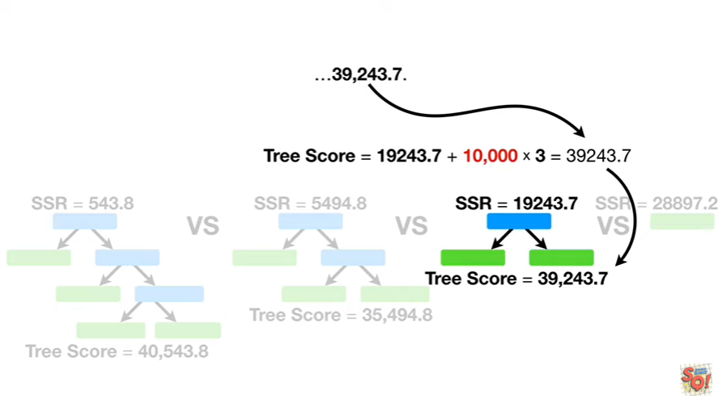

thirty-nine thousand two hundred forty three point seven.

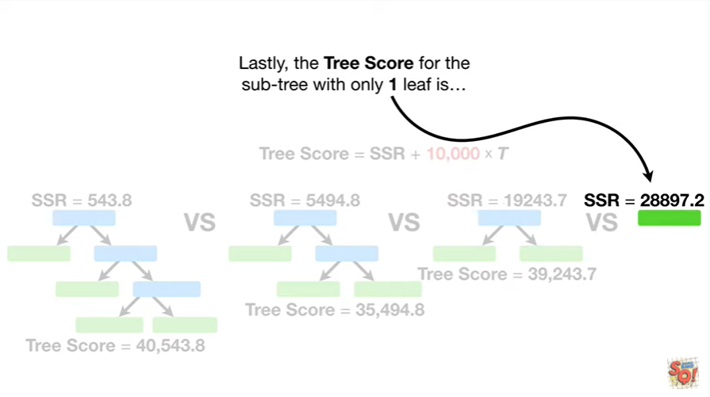

Lastly, the tree score for the subtree with only one leaf is

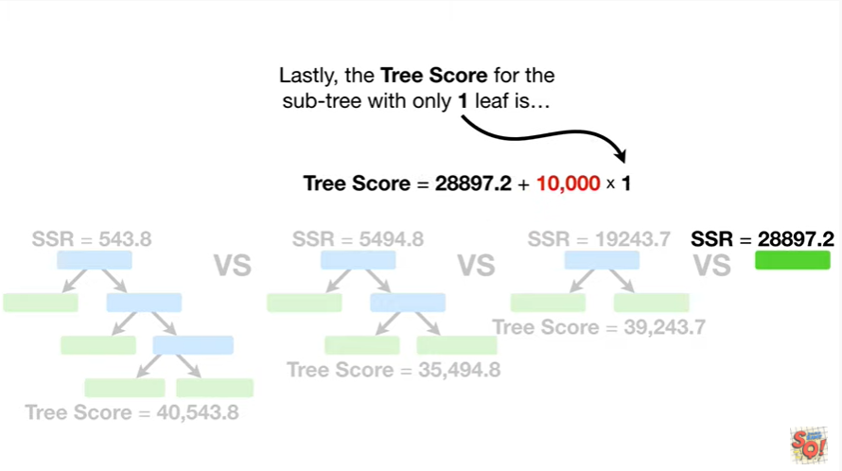

EP boopy boopy boopy boopy

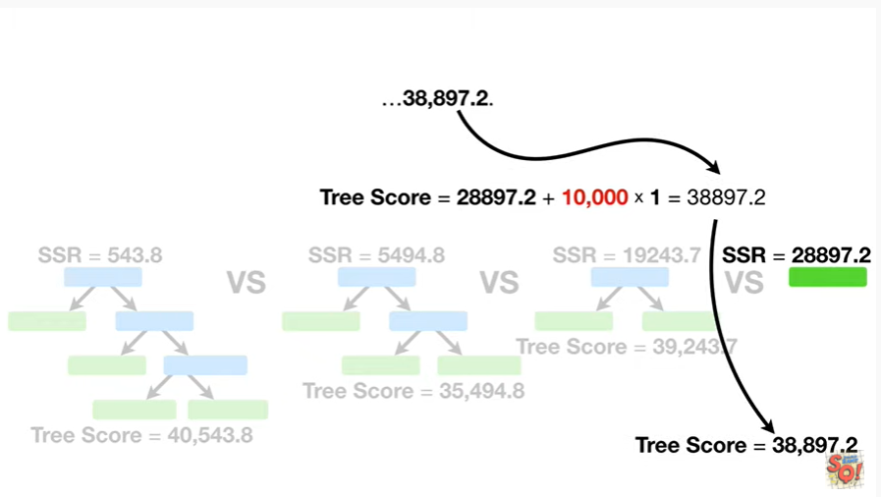

38 thousand eight hundred ninety seven point two.

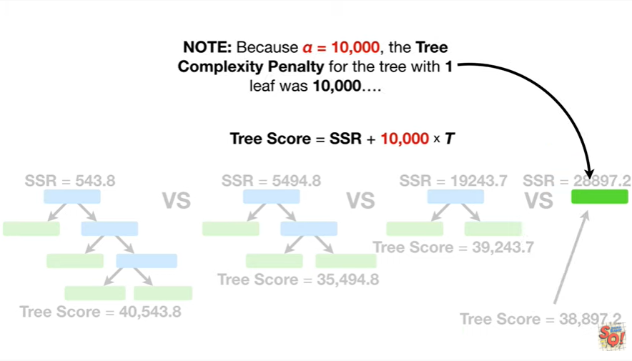

Note : because alpha equals 10,000, the tree complexity penalty for the tree with one leaf was 10,000

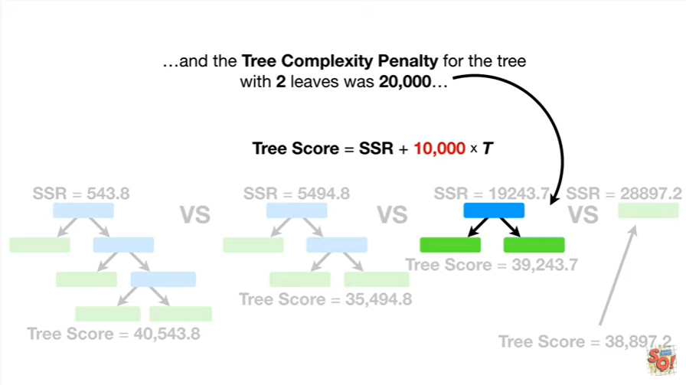

and the tree complexity penalty for the tree with two leaves was 20,000

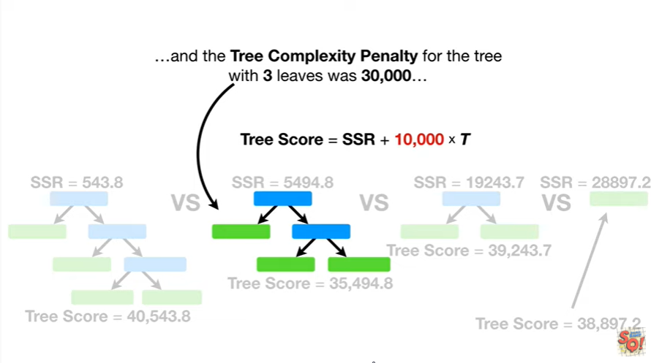

and the tree complexity penalty for the tree with three leaves was 30,000

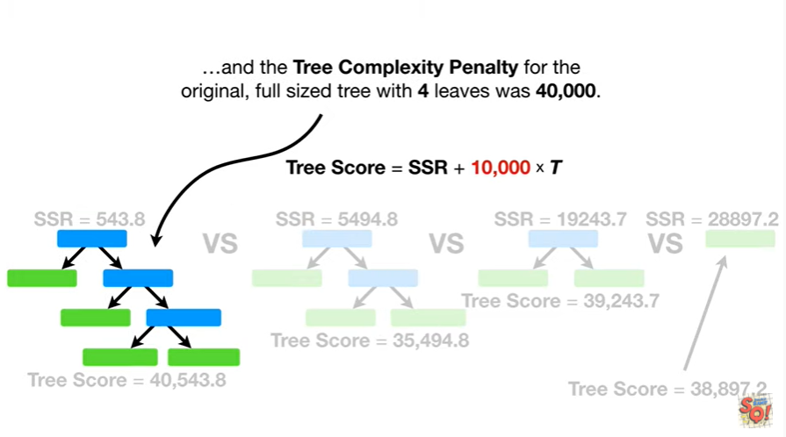

and the tree complexity penalty for the original full size tree with four leaves was 40,000.

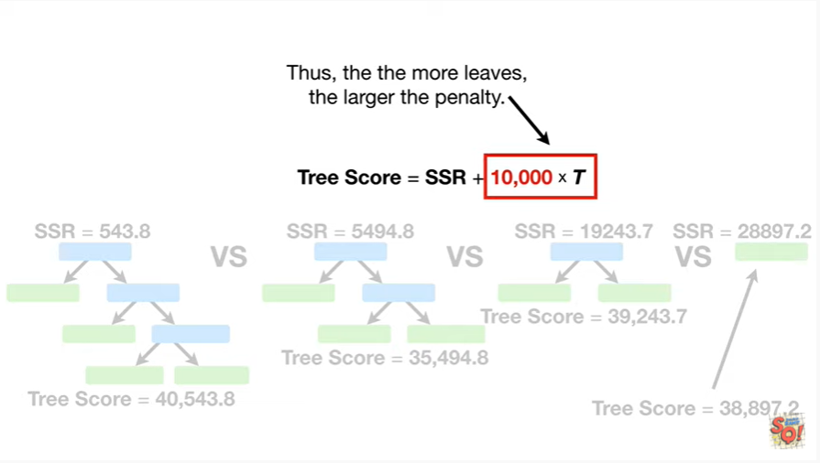

Thus the more leaves the larger the penalty.

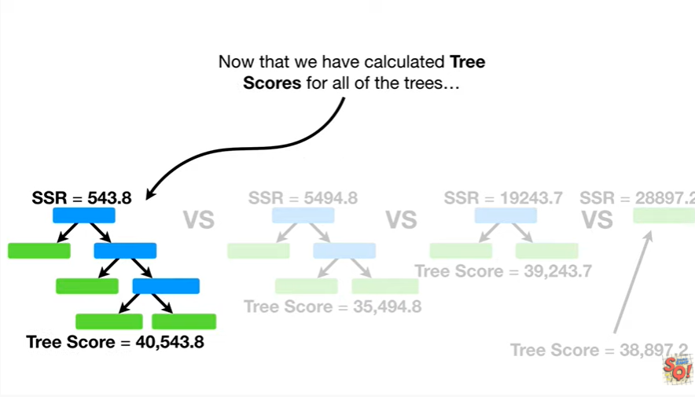

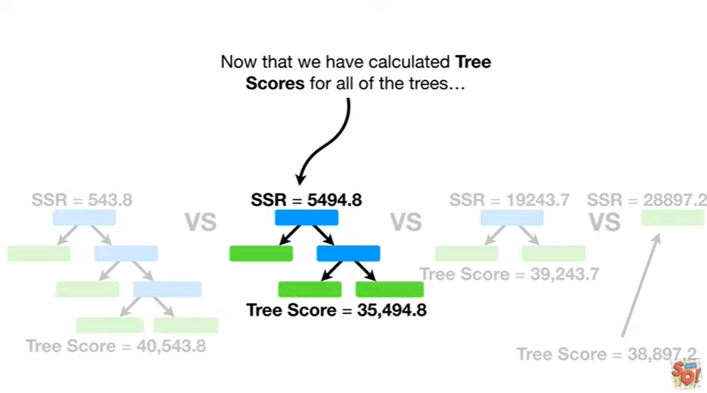

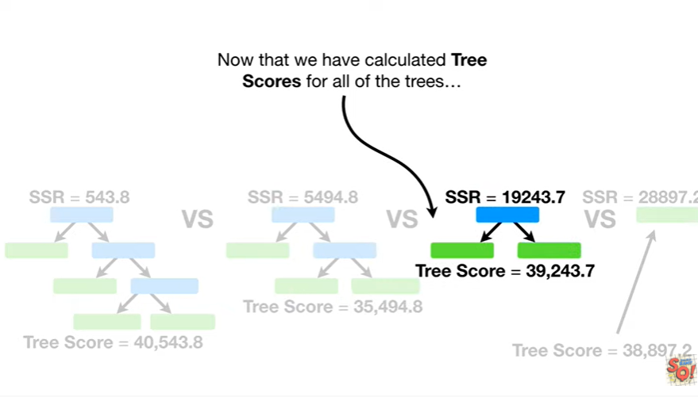

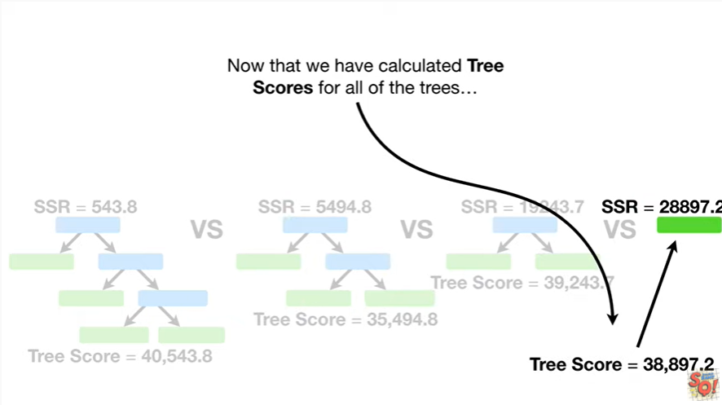

Now that we have calculated tree scores for all of the trees

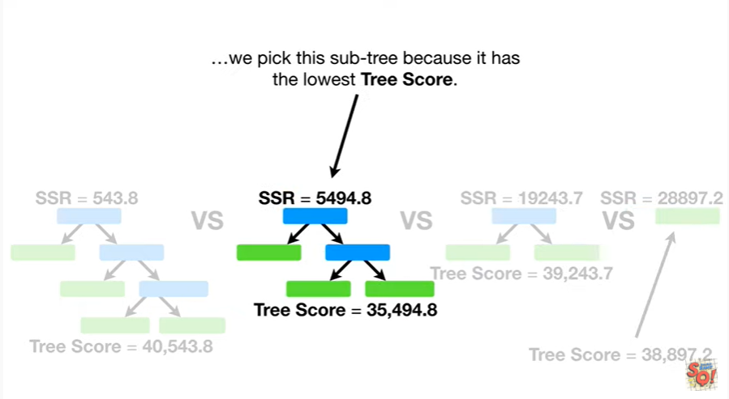

we pick this subtree because it has the lowest tree score.

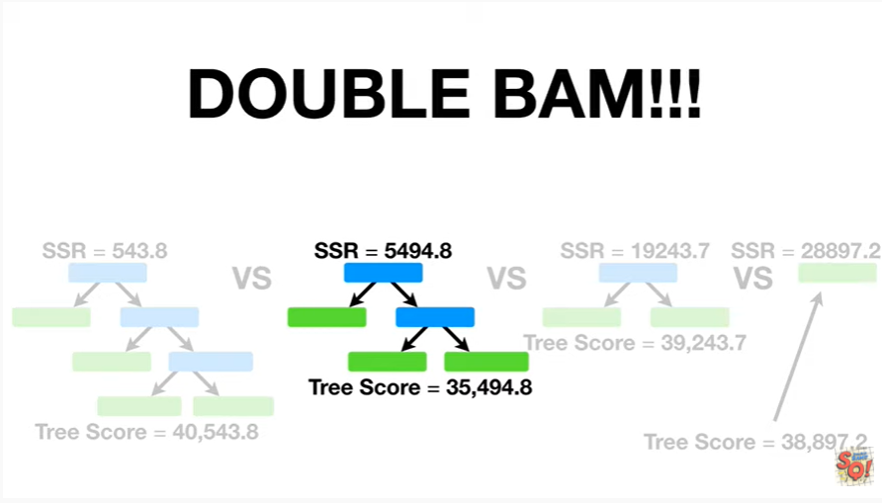

Double bam !!!

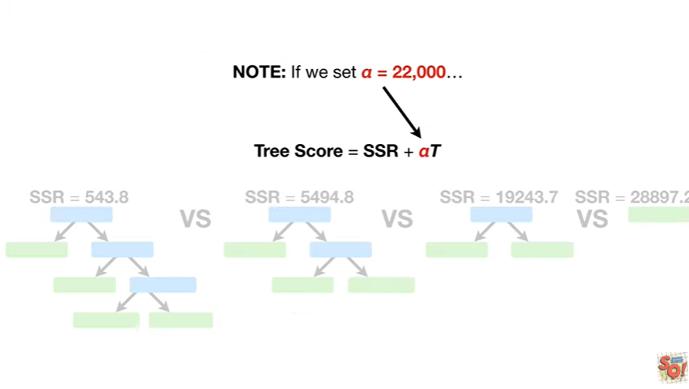

Note : if we set alpha equals 22,000

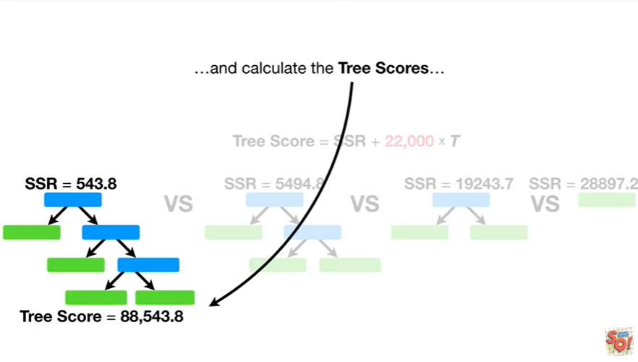

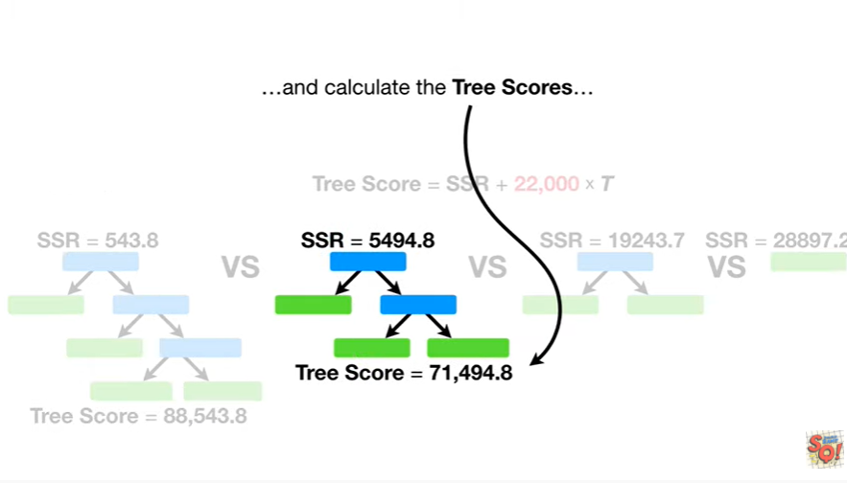

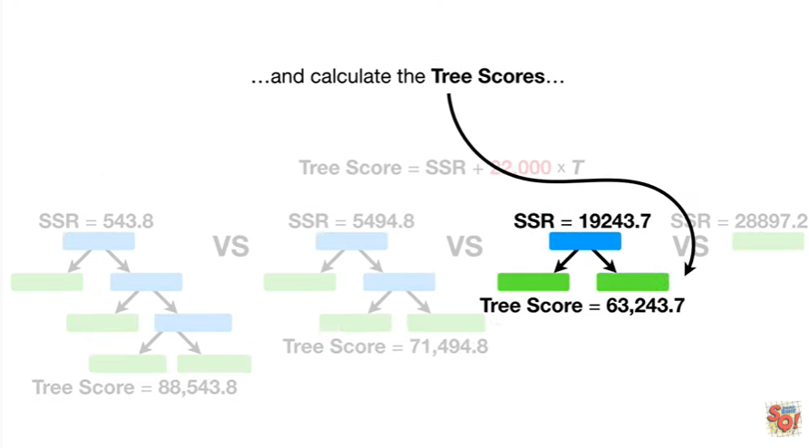

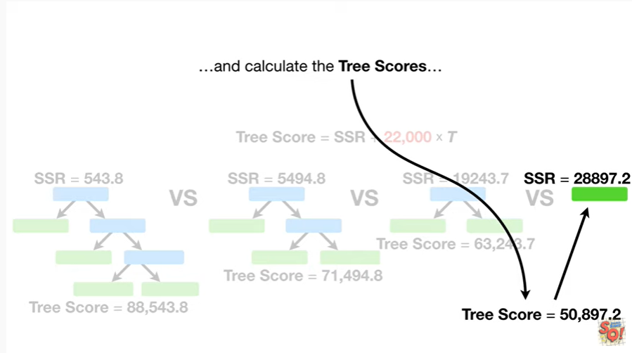

and calculate the tree scores

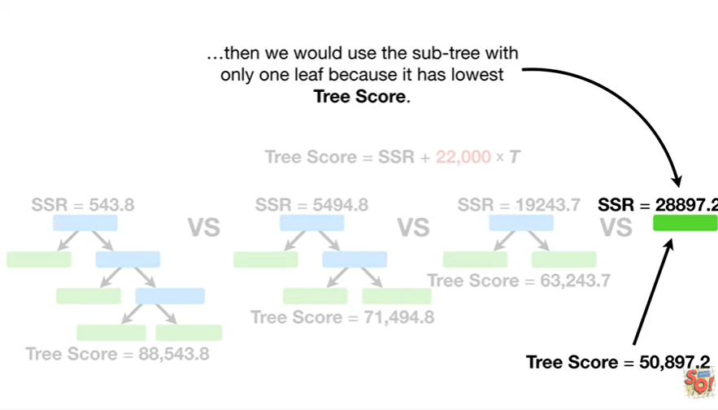

then we would use the subtree with only one leaf because it has the lowest tree score.

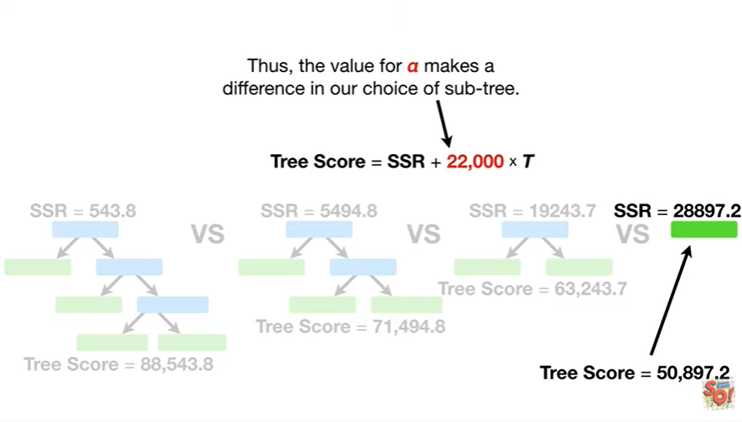

Thus the value for alpha makes a difference in our choice of subtree.

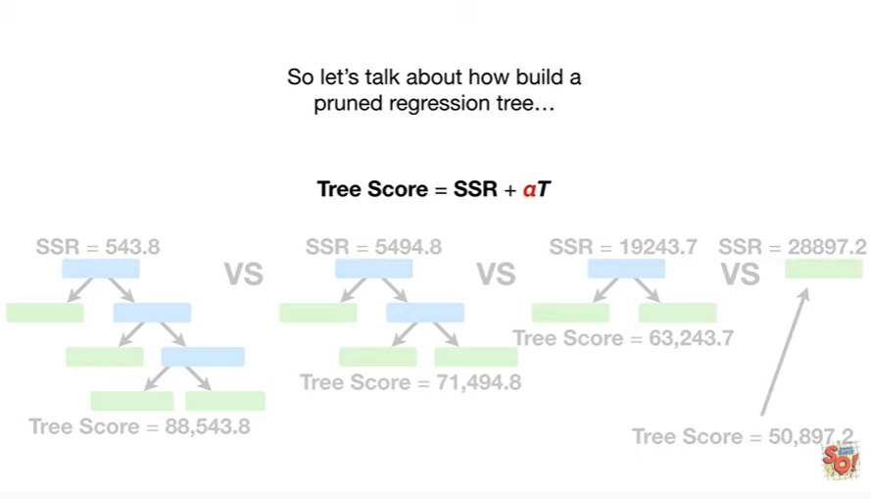

So let's talk about how to build a pruned regression tree

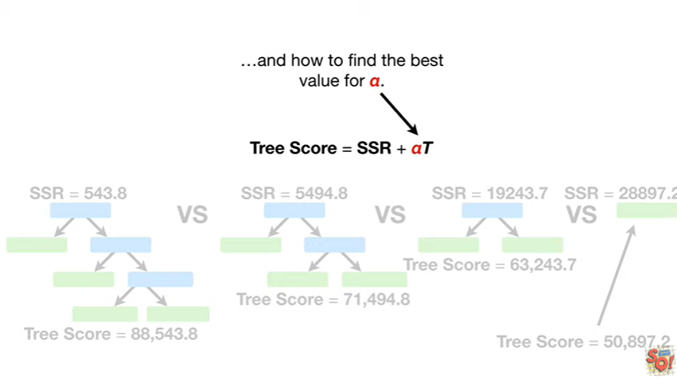

and how to find the best value for alpha.

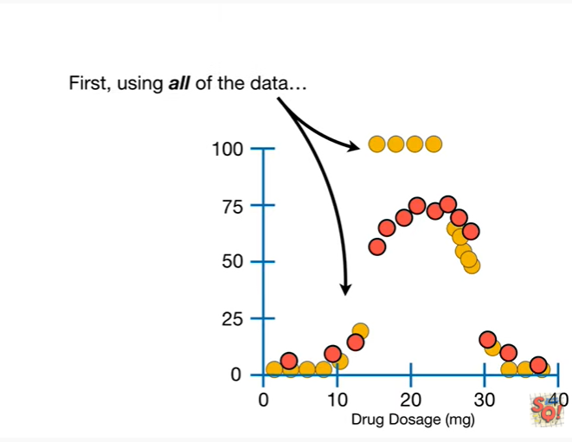

First using all of the data

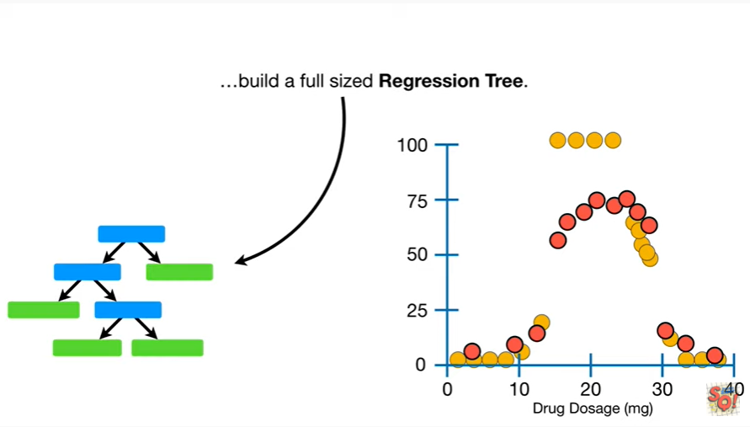

build a full sized regression tree.

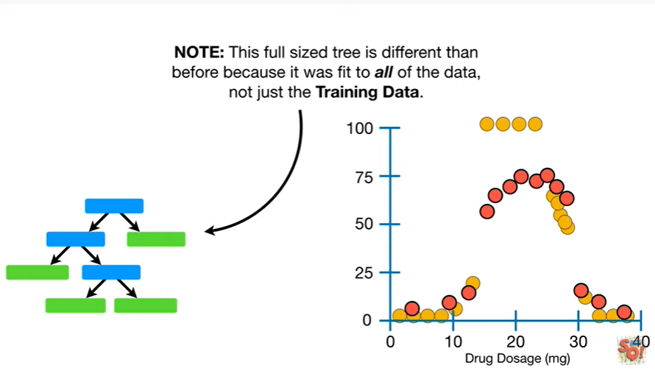

Note : this full size tree is different than before because it was fit to all of the data not just the training data.

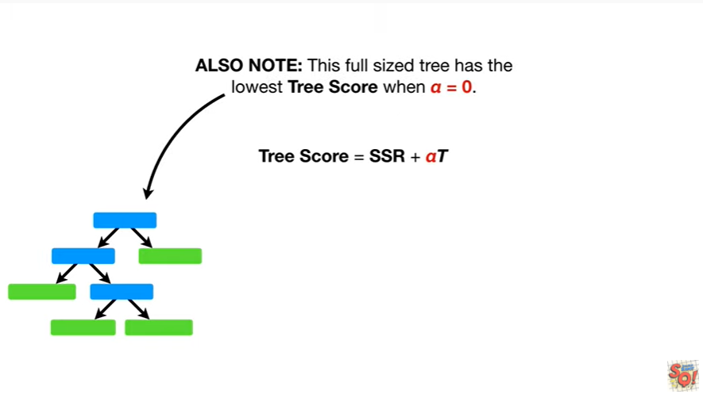

Also note this full-size tree has the lowest tree score when alpha equals zero.

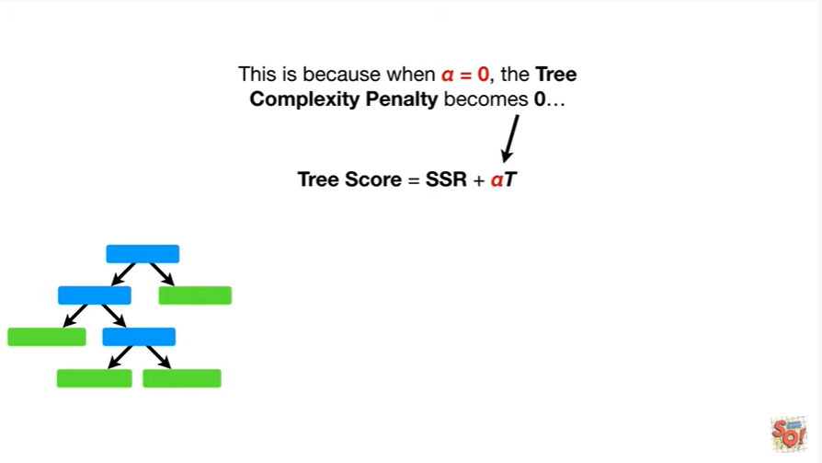

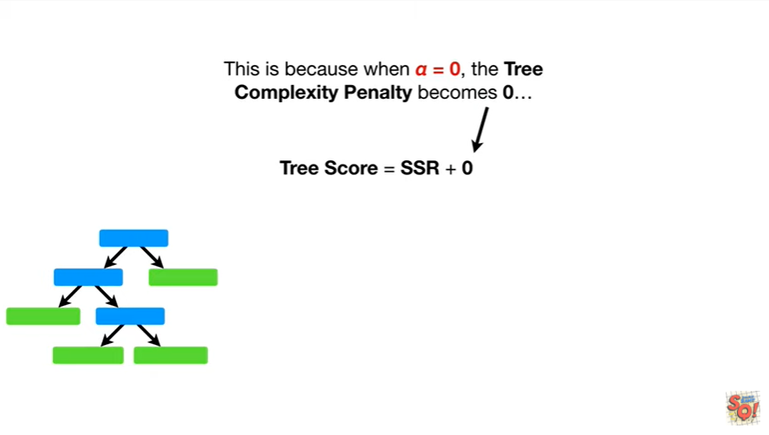

This is because when alpha equals zero the tree complexity penalty becomes zero

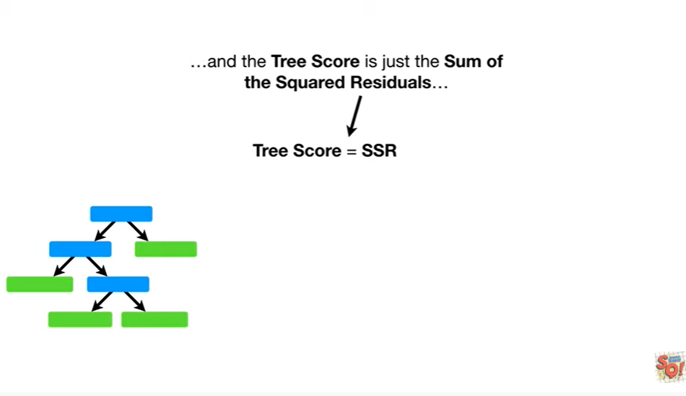

and the tree score is just the sum of the squared residuals

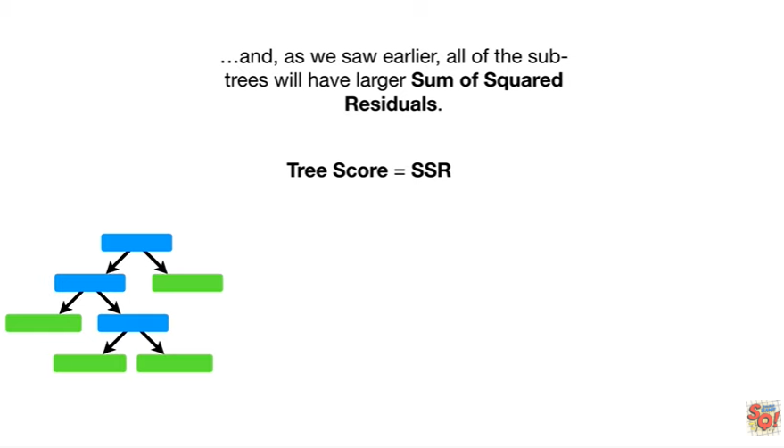

and as we saw earlier all of the sub trees will have larger sum of squared residuals.

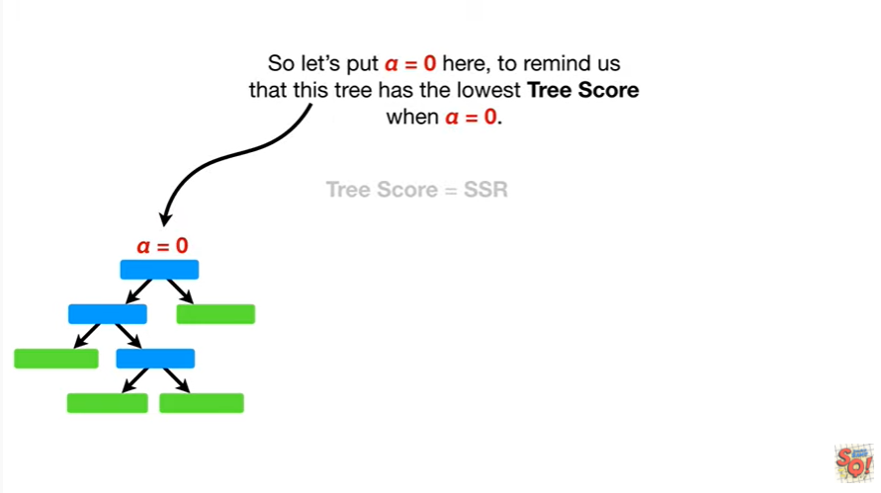

So let's put alpha equals zero here, to remind us that this tree has the lowest tree score when alpha equals zero.

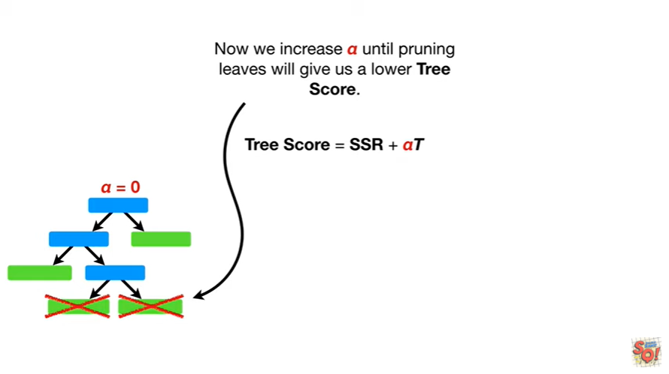

Now we will increase alpha until pruning leaves will give us a lower tree score.

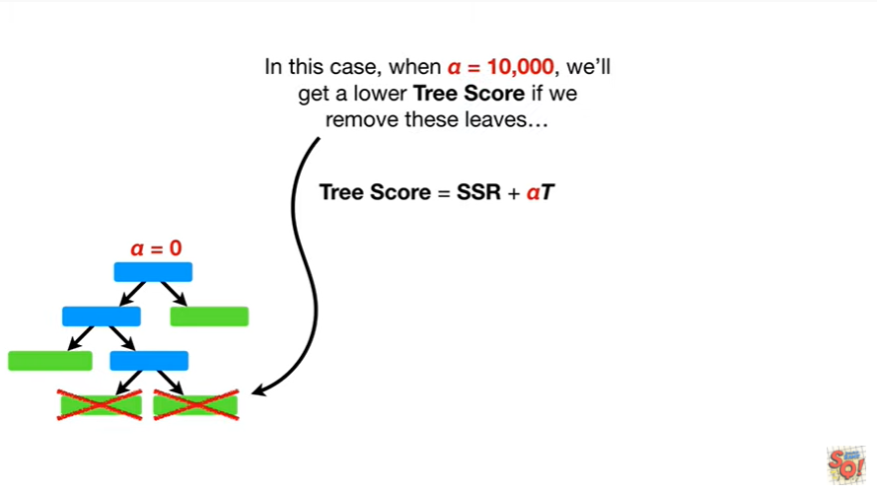

In this case when alpha equals 10,000 we'll get a lower tree score if we remove these leaves

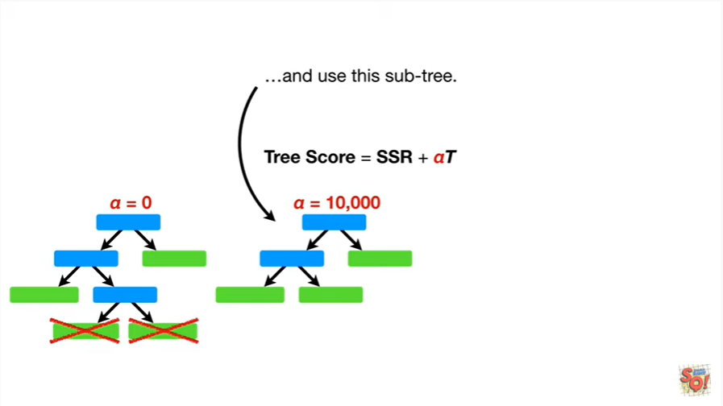

and use this sub tree.

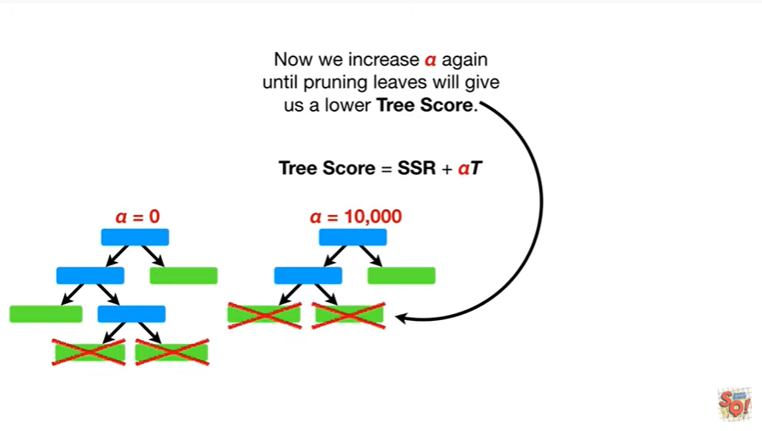

Now we increase alpha again until pruning leaves will give us a lower tree score.

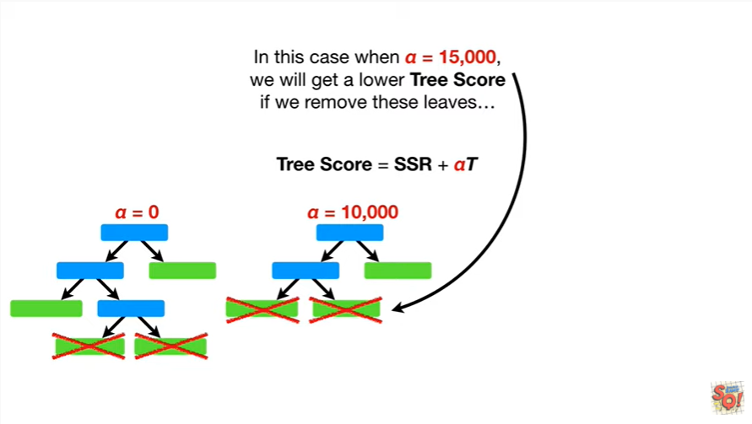

In this case when alpha equals 15,000 we will get a lower tree score if we remove these leaves

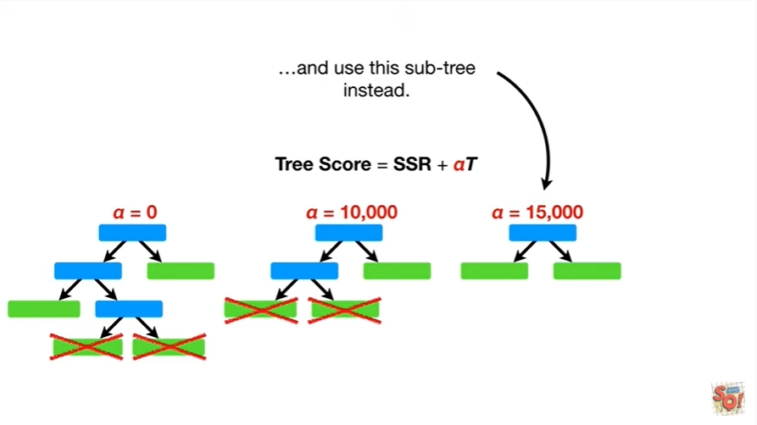

and use this sub tree instead.

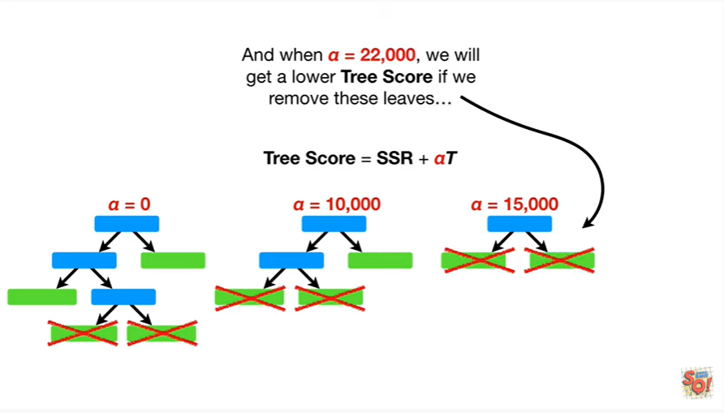

And when alpha equals 22,000 we will get a lower tree score if we remove these leaves

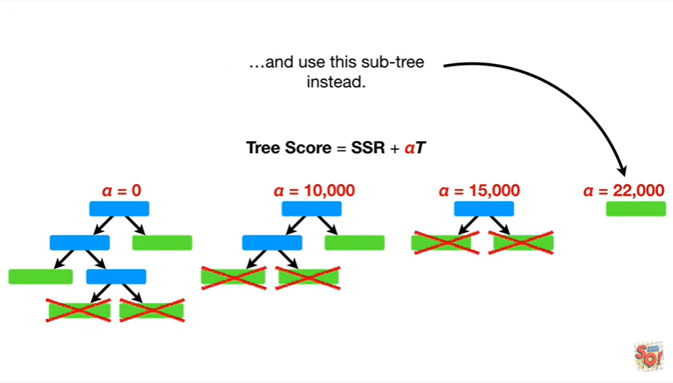

and use this subtree instead.

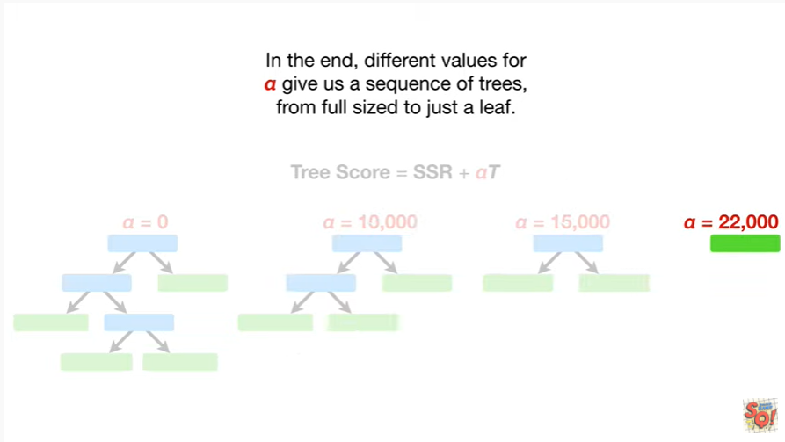

In the end, different values for alpha give us a sequence of trees, from full sized to just a leaf.

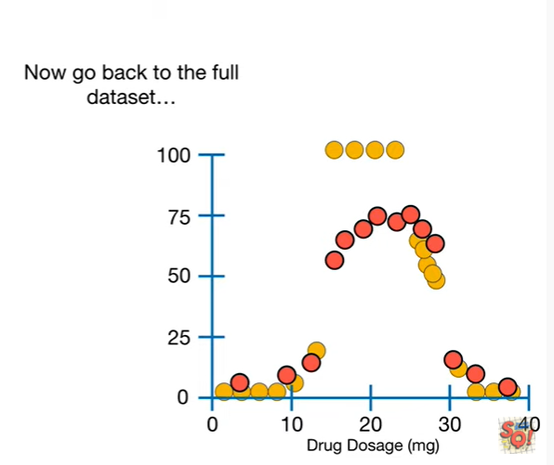

Now go back to the full data set

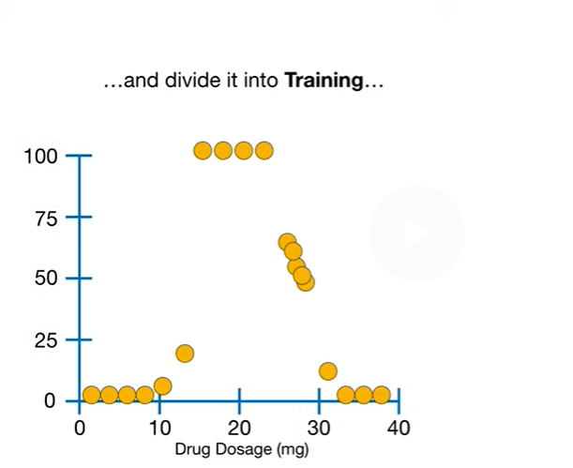

and divided into training

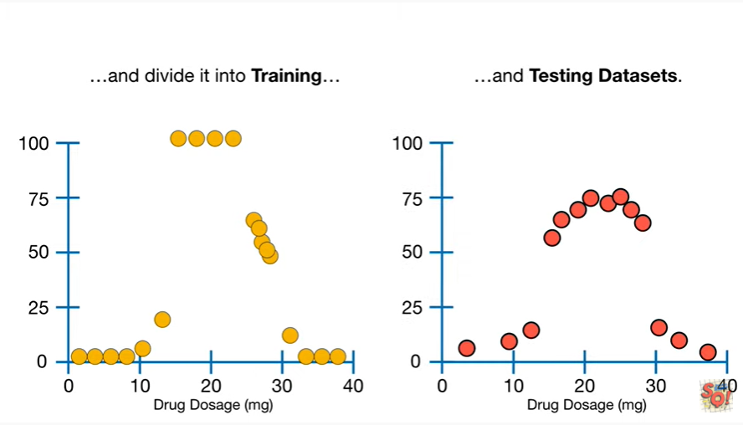

and testing data sets.

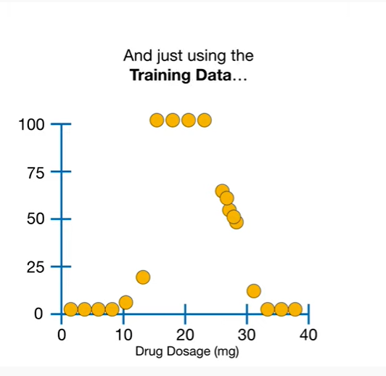

And just using the training data

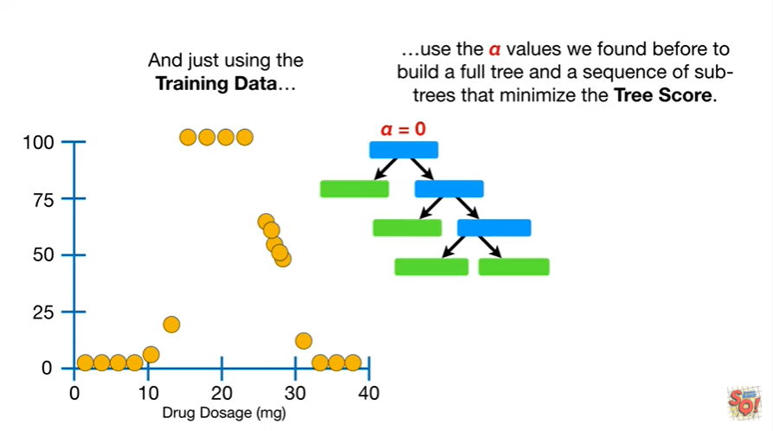

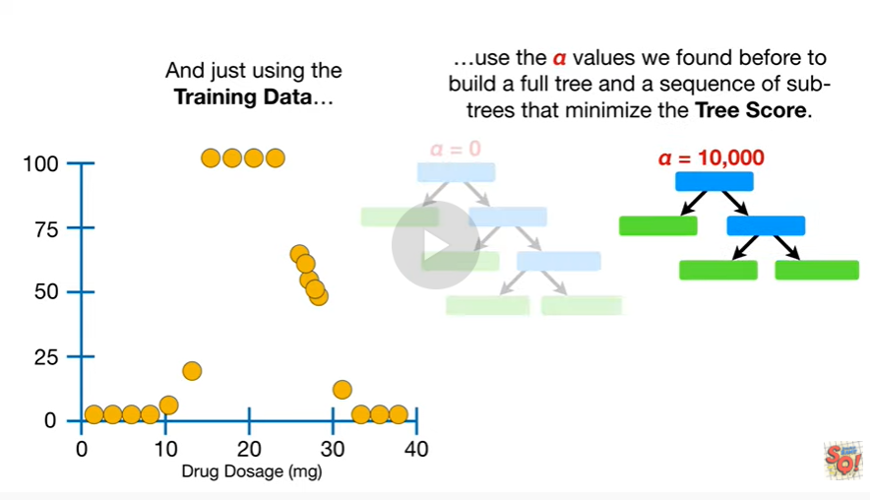

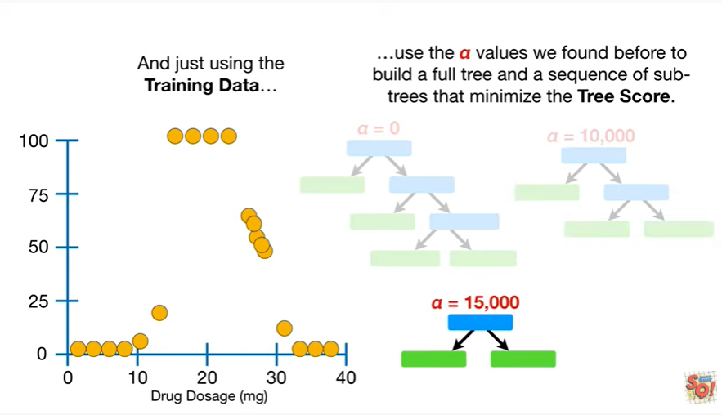

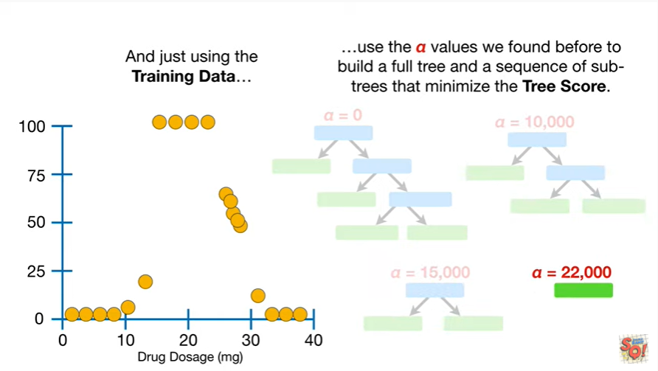

use the Alpha values we found before to build a full tree and a sequence of sub trees that minimize the tree score.

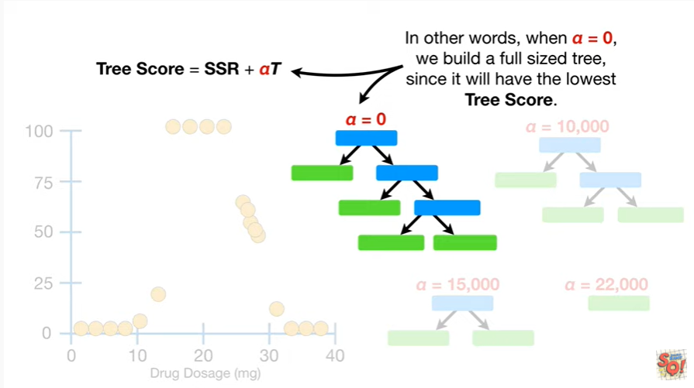

In other words, when alpha equals zero, we build a full-sized tree, since it will have the lowest tree score.

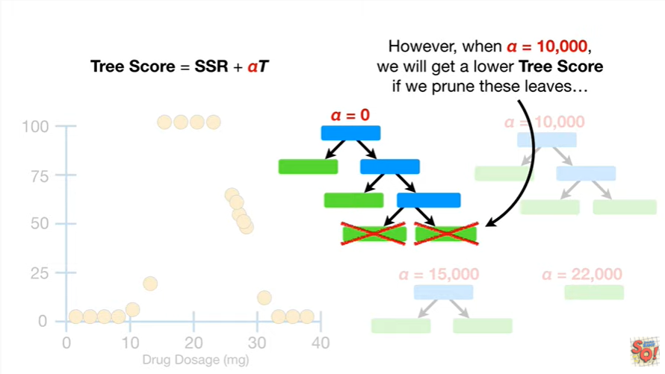

However, when alpha equals 10,000 we will get a lower tree score if we prune these leaves

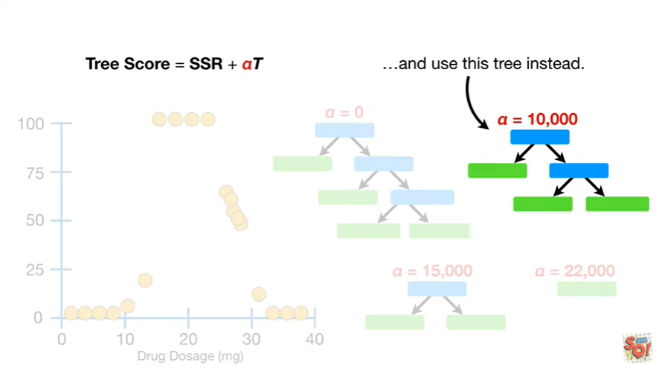

and use this tree instead.

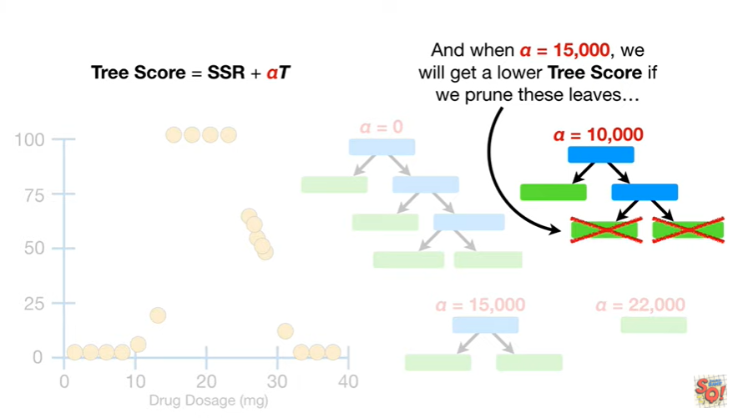

And when alpha equals 15,000 we will get a lower tree score if we prune these leaves

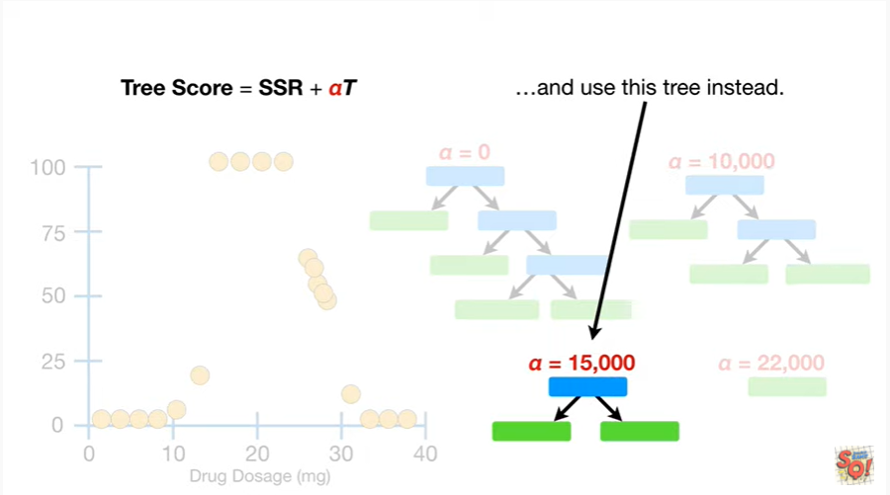

and use this tree instead.

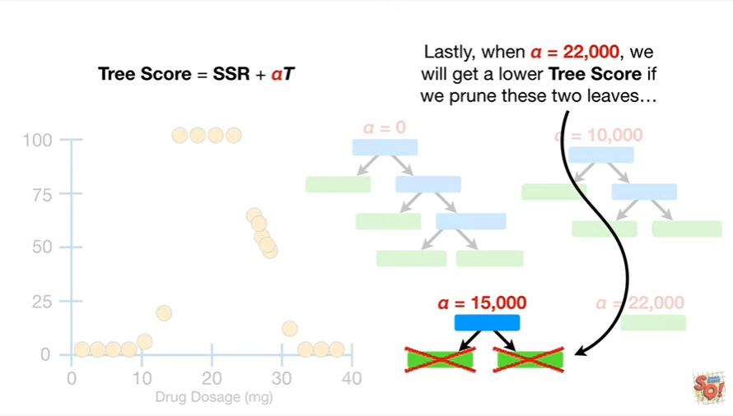

Lastly, when alpha equals 22,000, we will get a lower tree score if we prune these two leaves

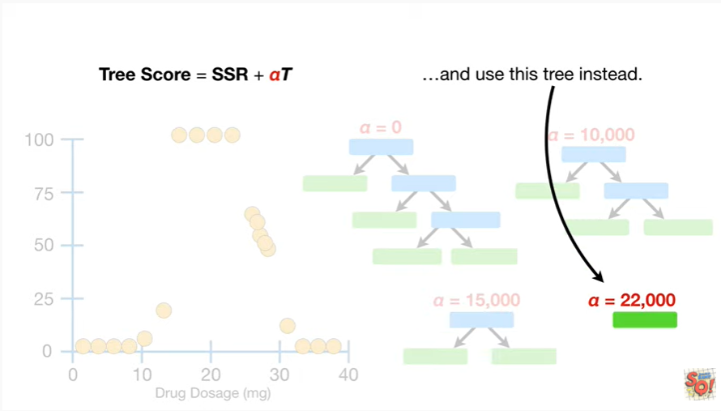

and use this tree instead.

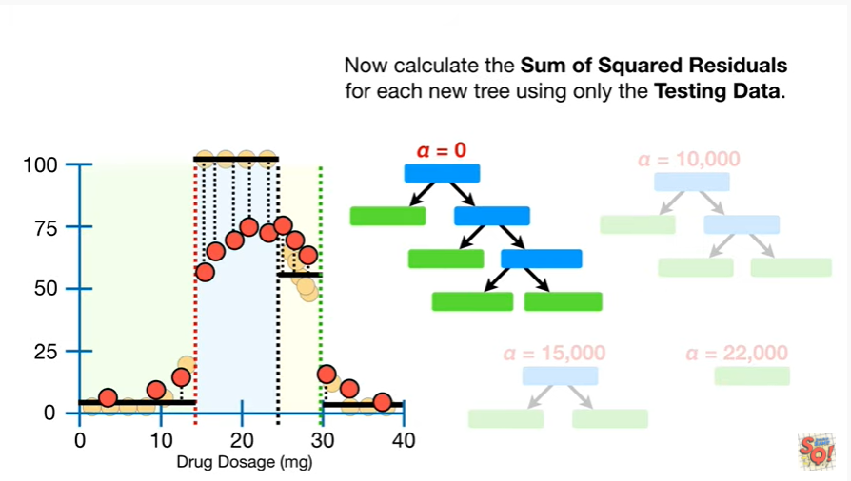

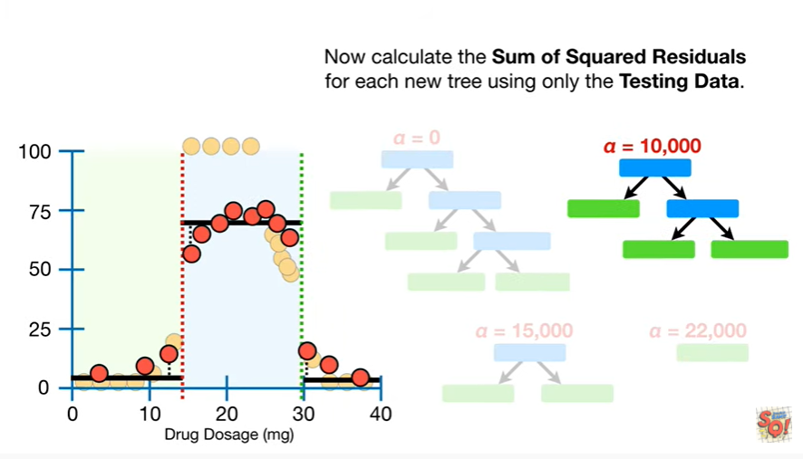

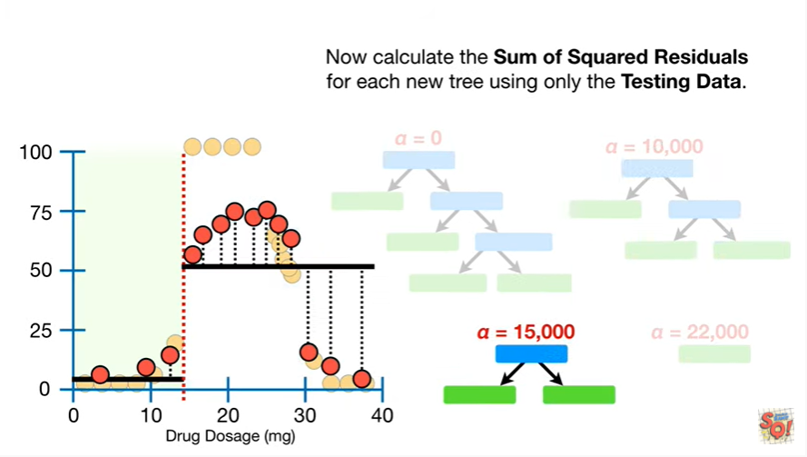

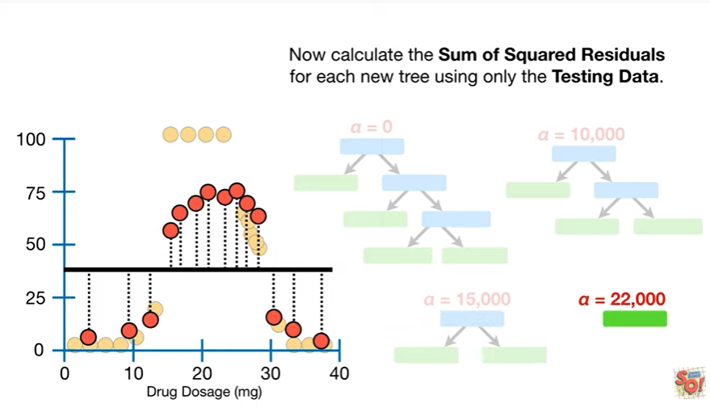

Now calculate the sum of squared residuals for each new tree using only the testing data.

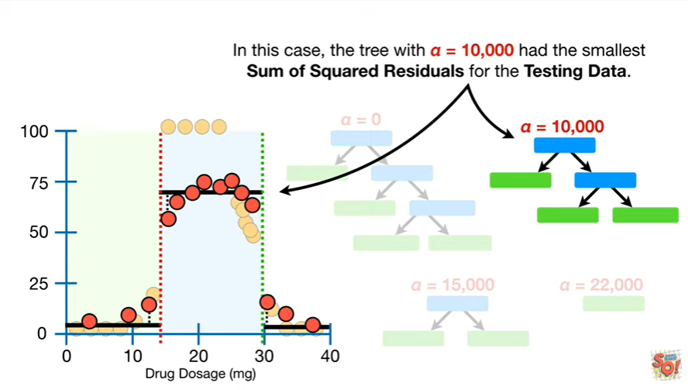

In this case the tree with alpha equals 10,000 had the smallest sum of squared residuals for the testing data.

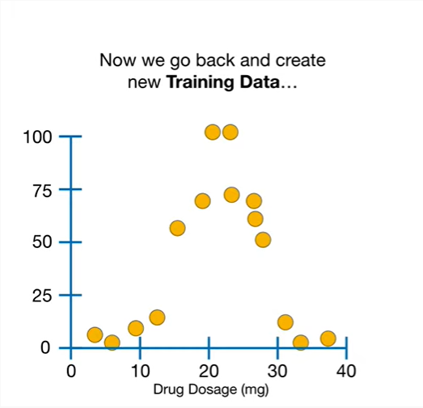

Now we go back and create new training data

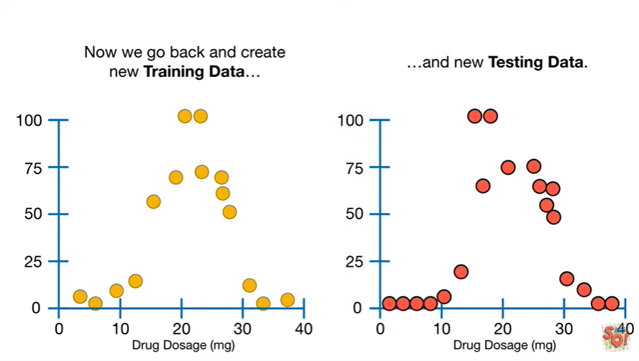

and a new testing data.

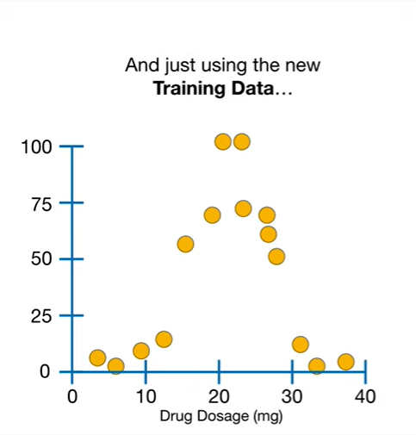

And just using the new training data

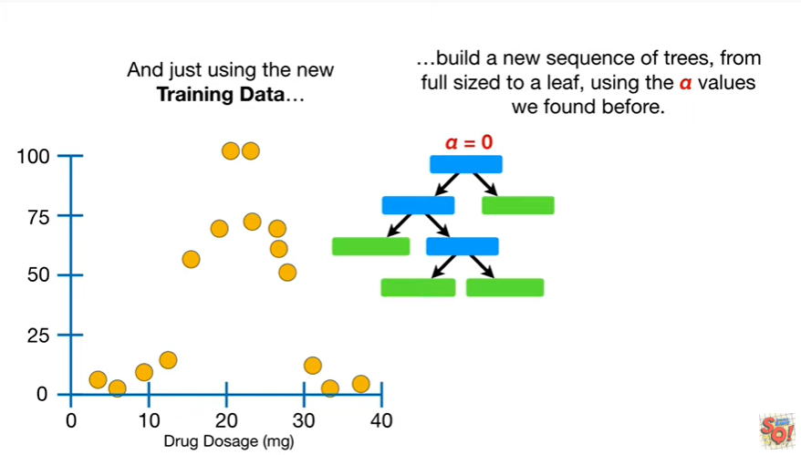

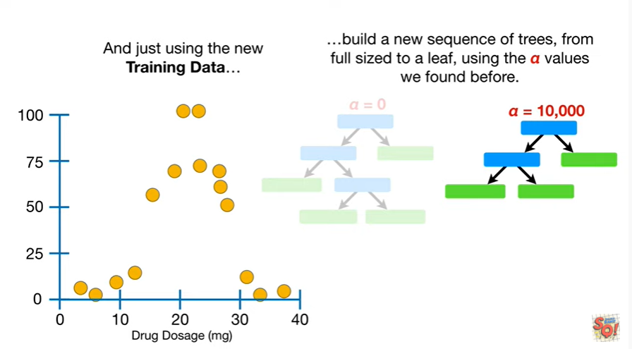

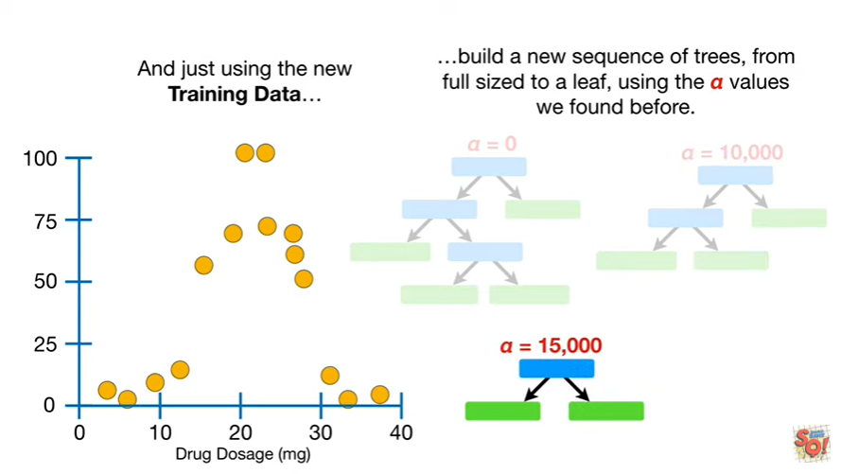

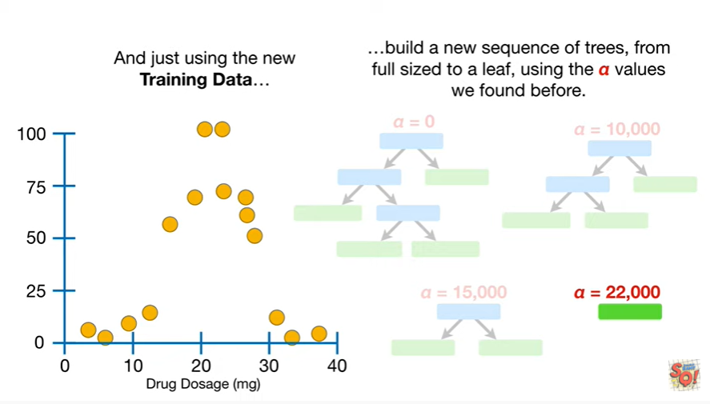

build a new sequence of trees from full sized to a leaf using the Alpha values we found before.

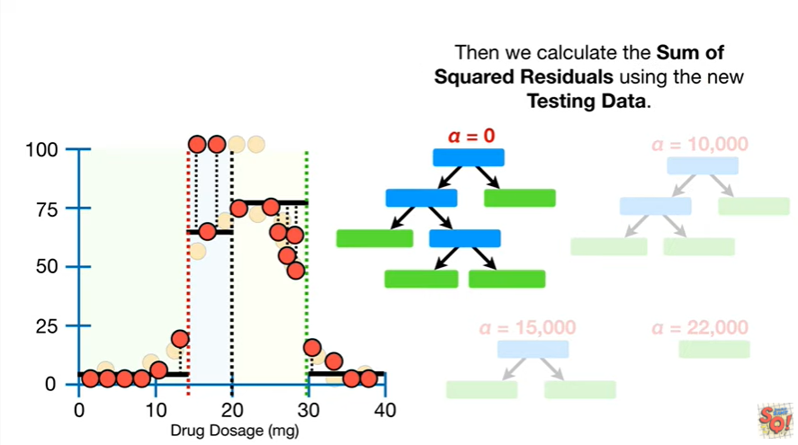

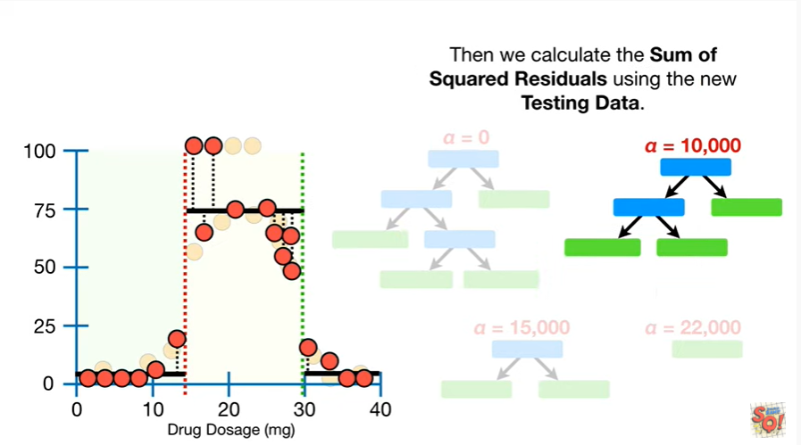

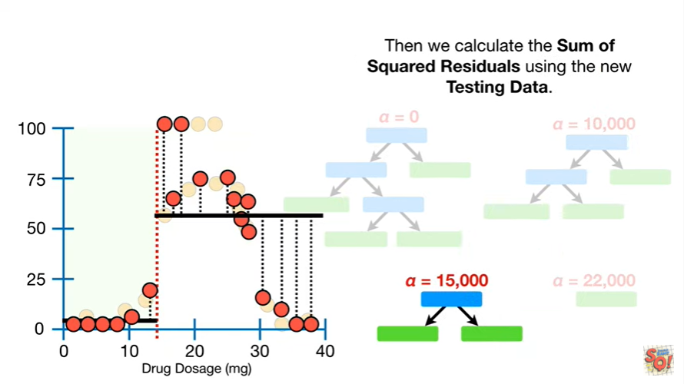

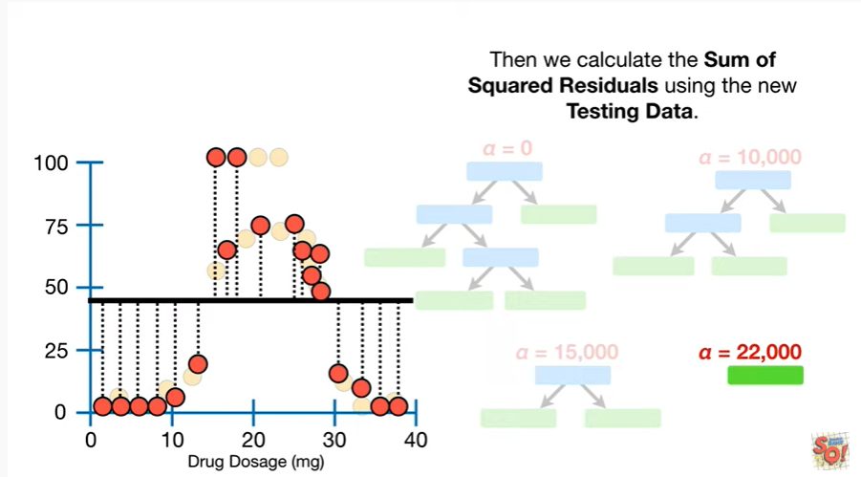

Then we calculate the sum of squared residuals using the new testing data.

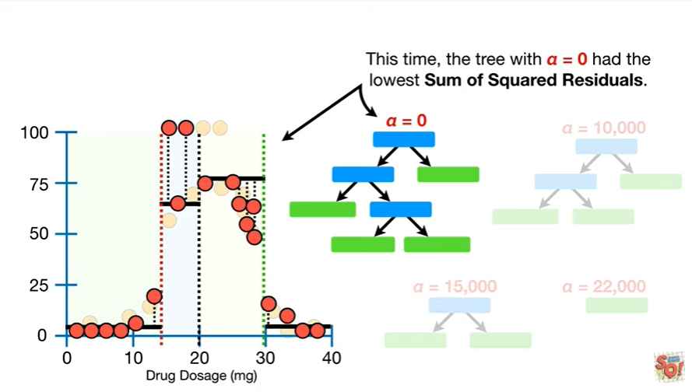

This time the tree with alpha equals zero had the lowest sum of squared residuals.

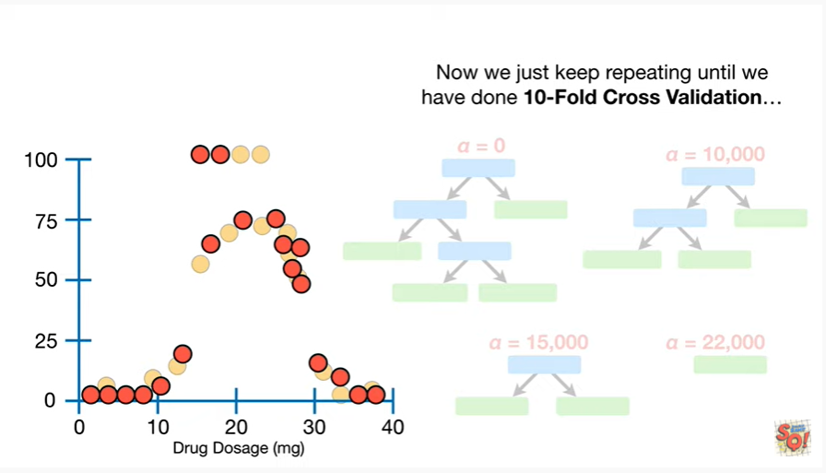

Now we just keep repeating until we have done 10-fold cross-validation

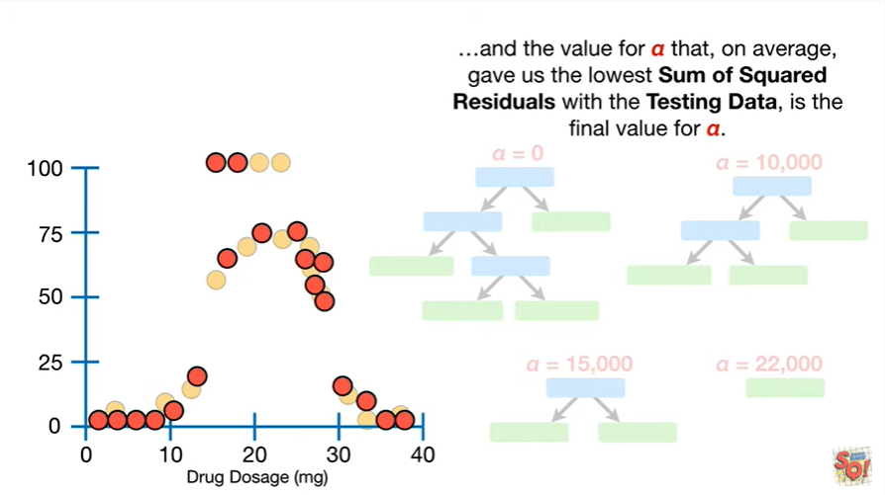

and the value for alpha that, on average, gave us the lowest sum of squared residuals with the testing data, is the final value for alpha.

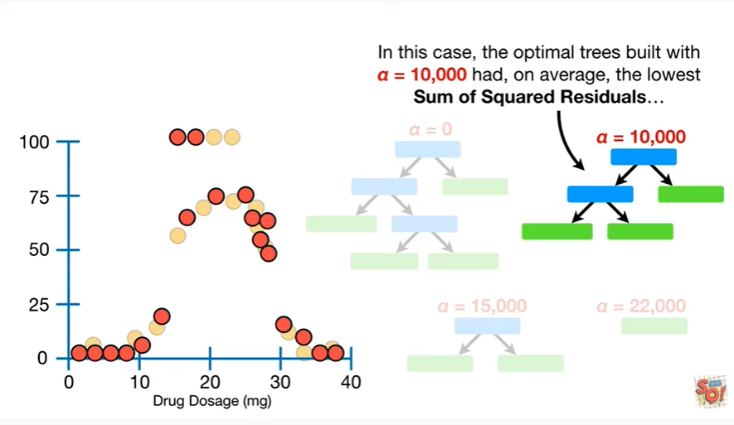

In this case, the optimal trees built with alpha equals 10,000 had, on average, the lowest sum of squared residuals

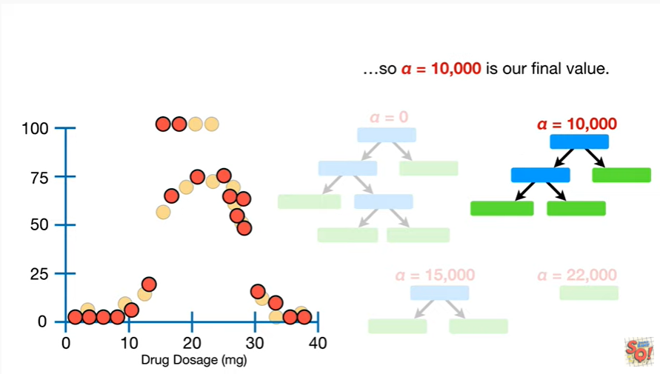

so alpha equals 10,000 is our final value.

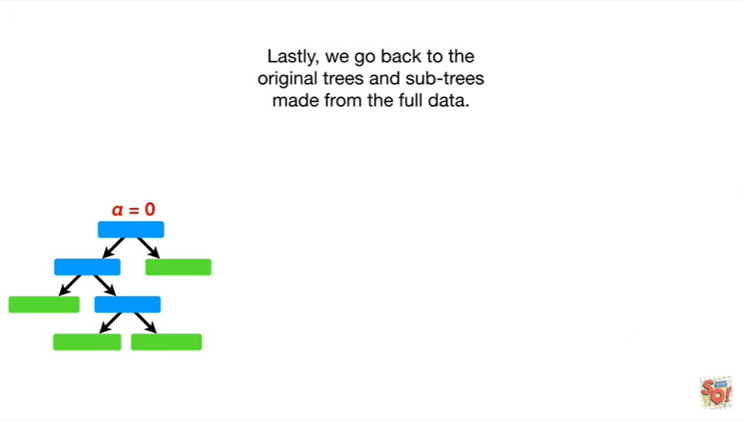

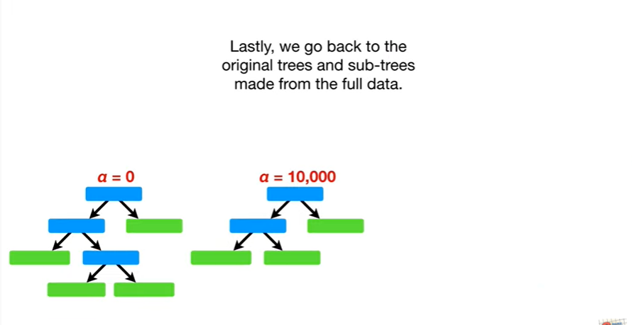

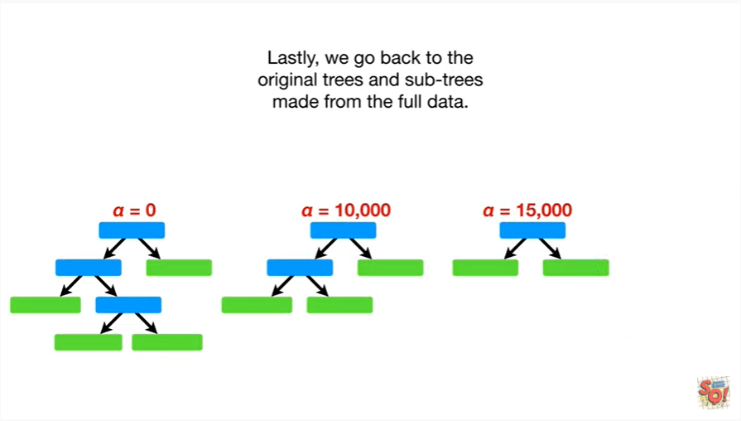

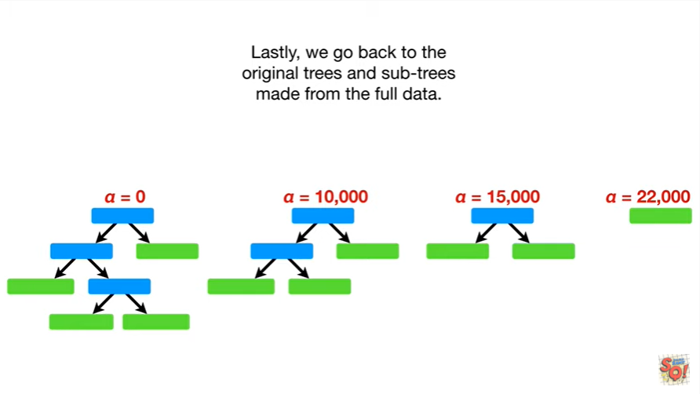

Lastly we go back to the original trees and sub trees made from the full data

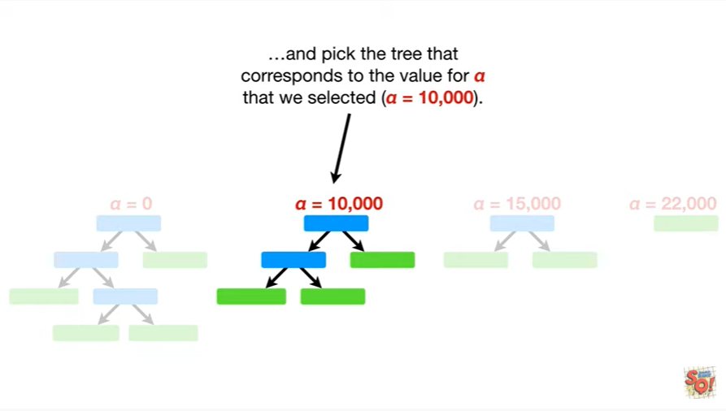

and pick the tree that corresponds to the value for alpha that we selected (alpha = 10 000.

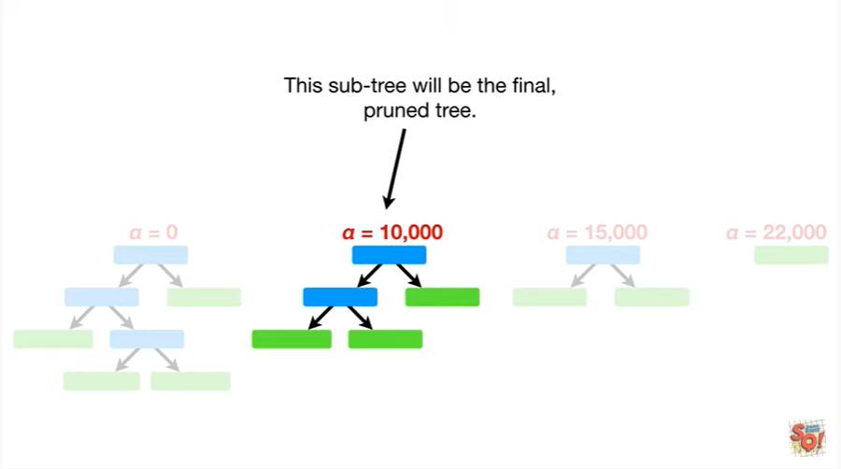

This sub-tree will be the final pruned tree.

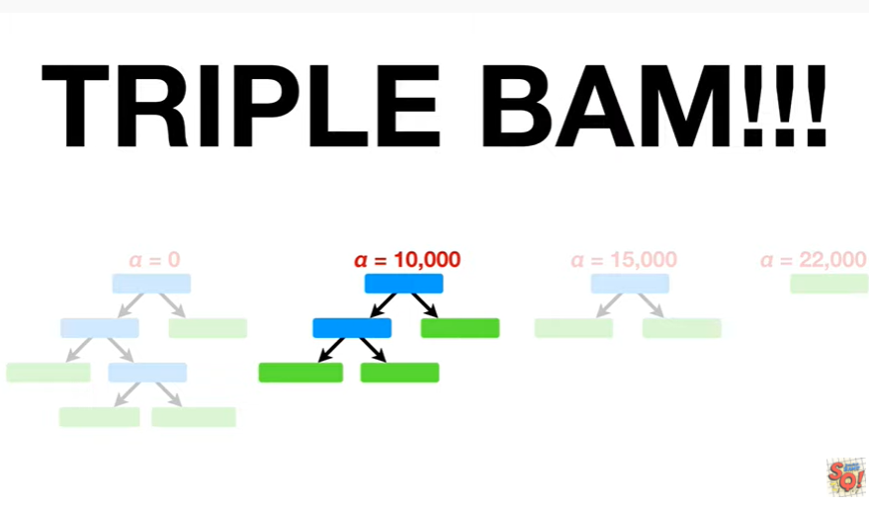

Triple bam !!!